REPUBLIC OF KENYA COUNTY GOVERNMENT OF MOMBASA

REQUEST FOR PROPOSAL FOR
URBAN RENEWAL AND REDEVELOPMENT OF OLD ESTATES WITHIN MOMBASA COUNTY
THROUGH
JOINT VENTURE PARTNERSHIP. LOT NO. 5 - TUDOR ESTATE
BID NO: CGM/PRO/T/001/2019-2020 JUNE, 2019

Table of Contents

DEFINITIONS 4
DISCLAIMER 8
SECTION I:INTRODUCTION 10
PROJECT IMPLEMENTATION STRATEGY 13
Project Implementation Strategy 13
JOINT VENTURE STRUCTURE 14
DEALING WITH EXISTING TENANTS 17
MANAGEMENT COMPANY 17
REPRESENTATIVES OF THE PARTIES 18
CONTRACTING AUTHORITY’S REPRESENTATIVE (S) 18
DEVELOPMENT PARTNER’S REPRESENTATIVE (S) 19
TUDOR ESTATE 20
Site Overview 20
SECTION II: INVITATION TO SUBMIT BID(S) 23
SECTION III: INSTRUCTIONS TO BIDDERS 25
A: GENERAL 25
B: BID DOCUMENTS 25
C: PREPARATION OF BIDS 25
D: SUBMISSION OF BIDS 26
E: BID OPENING AND EVALUATION 26
F: AWARD OF CONTRACT 26
- GENERAL 27
  - Purpose of this Document 27
  - Eligibility and Qualification Requirements 27
3.2.2 Eligibility Criteria 28
  - Cost of Bidding 30
  - Site Visit 30
- BID DOCUMENTS 32
  - Contents of Bid Documents 32
  - Inquiries by Bidders: 32
  - Amendment of Bid Documents 33
- PREPARATION OF BIDS 34
  - Language of the Bid: 34
  - Documents Comprising the Bid: 34
  - Currencies of the Bid 34
  - Bid Validity 34
  - Bid Security 35
  - Project Development Fee 37
  - No Alternative Offers: 37
  - Format and Signing of Bid 38
- SUBMISSION OF BIDS 40
  - Sealing and Marking of Bids 40
  - Deadline for Submission of Bids 41
  - Modification and Withdrawal of Bids 42
- BID OPENING AND EVALUATION 44
  - Bid Opening 44
  - Process to be Confidential 45
  - Clarification of Bids 45
  - Evaluation of Bids 47
- AWARD OF CONTRACT 51
  - Award 51
  - Notification of Award and Signing of the Joint Venture Agreement 51
  - Performance Guarantee 53
  - Corrupt or Fraudulent Practices: 53
  - Appendix to Instructions to Bidders: 53
ANNEX A - APPENDIX TO INSTRUCTIONS TO BIDDERS 55
SECTION IV: PROJECT OUTPUT SPECIFICATIONS 58
Architectural Concept Designs 58
THE ARCHITECTURAL CONCEPT DESIGNS 59
SECTION V: TECHNICAL PROPOSAL 71
Technical Proposal Evaluation 71
ANNEX B – TECHNICAL BID REQUIREMENTS 72
CONSTRUCTION TECHNOLOGY (CTP - 20 points) 73
WORK PLAN (25 points) 75
COMPLETION PERIOD (25 Points) 76
SECTION VI: FINANCIAL PROPOSAL 77
6.1 The Financial Bid 77
ANNEX C- FINANCIAL BID FORM 1 81
ANNEX D - FINANCIAL BID FORM 2 82
FINANCIAL EVALUATION CRITERIA 84
SECTION VII :GENERAL OUTLINE OF THE CONDITIONS OF CONTRACT 87
GENERAL OUTLINE OF THE CONDITIONS OF THE CONTRACT 89
- DESIGN REQUIREMENTS 91
- CONDUCT OF CONSTRUCTION WORK 97
- INTERPRETATION AND ADHERENCE TO CONTRACT REQUIREMENTS 118

DEFINITIONS
The following terms used in these Bid Documents shall have the meaning given to them unless otherwise defined herein below:

TERM | DEFINITION
Bank guarantee | Shall mean a guarantee from a reputable bank duly licensed by the Central Bank of Kenya to carry out banking business in Kenya.
Bid | Shall mean the proposal containing the ‘Mandatory Requirements’, ‘Technical Proposal’ and ‘Financial Proposal’ as submitted by a Bidder in response to this RFP Document.
Bidding Entity | Shall mean a single entity (Sole Proprietorship / Private Limited Company) or a partnership firm submitting a bid for the Project.
Bidding Consortium | Shall mean a group of bidding entities jointly submitting a bid for the Project.
Bid Documents | Shall mean this Request for Proposal (RFP) together with all its attached Annexes and Standard Forms, Architectural and Engineering drawings.
Bid Security | Shall have a meaning as referred to in Section 3.12 of this RFP.
Bid Submission Deadline | Shall mean the final date and time for the Bidders to submit their Bids as noted in Annex A (Appendix to Instructions to Bidders).
Bid Validity Period | Shall mean the period during which Bids must remain valid as determined under Annex A (Appendix to Instructions to Bidders).
CGM | Shall mean the County Government of Mombasa.
Clause | A clause of these Bid Documents.
Consortium | Each entity in the Bidding Consortium shall be

Member | referred to as a “Consortium Member”.
Contract Period | Shall mean a period agreed between the two Parties and defined in the Joint Venture Agreement to be signed by both parties.
Contracting Authority | Shall mean the County Government of Mombasa (CGM).
Development Cost | Shall mean the development cost offered by a Bidder in the Financial Proposal for the development of the Project, which includes the construction costs, all taxes including Value Added Tax (V.A.T) payable, and profits expected from the Project by the development partner but excluding the cost of land.
Development Partner | Shall mean the Successful Bidder which shall by itself or through a Special Purpose Vehicle enter into a Joint Venture Agreement with CGM to develop the Project.
Escrow Account | A separate bank account for managing all funds and any proceeds pertinent to the Project.
Financial Proposal | Shall mean the Financial bid as submitted by the Bidder as per the format specified under Section VI in the Request for Proposal.
JBA | Means the Joint Bidding Agreement outlined in Standard Form VIII to be entered into among the members forming the Bidding Consortium.
JVA | Means the Joint Venture Agreement to be entered into by CGM and the Development Partner. “Joint

Venture Agreement”, “Contract” and

“Development Contract” are synonymous.
Lead Consortium Member (LCM) | Shall mean the Lead Consortium Member which shall be vested with the prime responsibility of developing the Project.
Letter of  Acceptance (LOA) | Shall mean the letter issued by CGM to the Successful Bidder and shall be as per terms mentioned in Clause 3.26
Project Name | Shall mean the Urban Renewal and Redevelopment of Old Estates within Mombasa County through Joint Venture Partnership. Lot No. 5 – Tudor Estate.
Project Facilities | Shall mean collectively all the facilities to be developed by the Development Partner at the Project Site in accordance with provisions of the Joint Venture Agreement.
Project Site | Shall mean the parcel of land at Tudor Estate whose site Cadastral Map is as attached in Section VIII.
Bidder | Shall mean the Bidding Entity or Bidding Consortium submitting a bid for this Project.
RFP | Means this Request for Proposal Document.
Security Agent | Shall mean an independent party to be agreed by both Parties before or after signing of the JVA and whose function shall be to establish the Escrow Account, receive money into the account, notify the transacting parties upon receipt of the same if required, and  facilitate the release of the money in accordance with

 | the prescribed conditions as outlined in the Escrow Agreement.
Successful Bidder | Shall mean the Successful Bidding Consortium or Bidding entity that attains the highest aggregated score in their technical and financial bids.
Technical Proposal | Shall mean the Technical Bid as submitted by the Bidder as per the format specified under Section V in the Request for Proposal.

DISCLAIMER
The County Government of Mombasa (CGM) has taken adequate care in the preparation of this Request for Proposal (RFP). Nevertheless, the Bidder should satisfy itself that the RFP is complete in all respects.

Neither CGM, nor its employees, consultants, advisors accept any liability or responsibility for the accuracy or completeness of, nor make any representation or warranty – express or implied, with respect to the information contained in the RFP, or on which the RFP is based, or any other information or representations supplied or made in connection with the Selection Process.

Neither CGM, nor its employees, consultants or advisors will have any liability to any Bidder or any other person under any law, statute, rules or regulations or otherwise for any loss, expense or damage which may arise from or be incurred or suffered in connection with any information contained in this RFP, the award of the Project, the information and any other information supplied by or on behalf of CGM or their employees, any consultants or otherwise arising in any way from the selection process for the Project.

The RFP does not address concerns relating to diverse investment objectives, financial situation and particular needs of each party. The RFP is not intended to provide the basis for any investment decision and each prospective Bidder must make its / their own independent assessment in respect of various aspects of the feasibilities of the Project. No person has been authorized by CGM to give any information or to make any representation not contained in the RFP

document.

Nothing in this RFP is, or should be relied on, as a promise or representation as to the future. In furnishing the RFP, neither CGM, nor its employees or advisors undertake to provide the recipient with access to any additional information or to update the RFP nor to correct any perceived inaccuracies therein.

CGM or its authorized officers / representatives / advisors reserve the right, without prior notice, to change the procedure for the selection of the Successful Bidder or terminate discussions and the delivery of information at any time before the signing of any agreement for the Project, without assigning reasons thereof.

CGM reserves the right to reject any or all of the Bids submitted in response to the RFP at any stage without assigning any reasons whatsoever.

CGM reserves the right to change any or all of the provisions of the RFP. Such changes will be intimated to all the Bidders.

CGM reserves the right to change, modify, add to or alter the selection process including adding other parameters to the evaluation criteria. Any change in the selection process shall be communicated to all Bidders.

SECTION I: INTRODUCTION
The County Government of Mombasa (CGM) (the “Contracting Authority”) in line with its responsibility for urban management as vested to it under the Urban Areas and Cities Act, 2011 intends to undertake an aggressive programme aimed at urban regeneration and renewal of its old estates within the County. This will ensure that the residents of Mombasa County will have access to sound and affordable modern housing with upgraded and greatly renewed support infrastructure. This being a fairly capital intensive undertaking, the County plans to implement the Project through joint venture partnerships with private investors.

The Investors will be expected to bring in the financing required to do the construction while the County Government will avail the land where the development will be undertaken. The Bidders will be expected to indicate in their bids the price they shall expect to be paid for each unit developed, upon which the County will then add a mark up to determine the sale price at which the houses will be offered to members of the Public to buy.

There shall be established an Escrow Account between the Private Developer and the County Government where the proceeds of sale of the houses will be deposited. The Private party shall be allowed to charge the land upon which the development shall be undertaken on condition that, any monies secured by charging the land are deposited into the escrow account and are strictly used for the development of the Project.

The designs of the estate have been prepared and the Successful Bidder will be required, by way of novation, to adopt them to implement the Project. Bidders may propose design changes but subject to the Contracting Authority’s approval.

The Project involves the development of a new Estate and redevelopment of 5 old Estates into modern housing estates with improved housing facilities and infrastructure to meet the rising demand for housing units in the County. These Estates are as follows and their Tenders have already been advertised:
  - Lot No. 1 - Khadija Estate;
  - Lot No. 5 – Tudor Estate;
  - Lot No. 7 – Buxton Estate;
  - Lot No. 10 – Tom Mboya Estate;
  - Lot No. 11 – Kaa Chonjo Estate;

The above sites currently have the following existing Housing Units:

Estate | No. of Existing Housing Units | Acreage
Khadija Estate | 100 | 22.7
Tudor Estate | 900 | 21
Buxton Estate | 520 | 14
Tom Mboya Estate | 32 | 1.5
Kaa Chonjo Estate | 100 | 18

The County therefore seeks development partners from the Construction Industry, Banking Industry, Pension Funds / Schemes, Real Estate Developers and other investors to participate in this project. Private parties can participate either as single entities or as Consortiums. Each of the five (5) Sites mentioned above will constitute a distinct contract for which separate Bids should be submitted. A Bidder can bid for more than one Lot.
Annex B herein shall only be relied upon where the bidder is providing the designs for the estate.

PROJECT IMPLEMENTATION STRATEGY
The project will be implemented on a Joint Venture arrangement basis. The formation of the Joint Venture (JV) partnership is contemplated under Section 6 (5) as read together with Section 74 of the County Governments Act No. 17 of 2012, Laws of Kenya.

Private investors have the opportunity to enjoy relatively high returns expected from the project as the current prohibitive cost of land in Mombasa County will not hinder their participation. The relationship between the CGM and the Development Partner(s) shall be governed by a Joint Venture Agreement and Parties shall appoint an Independent Technical expert to monitor the implementation of each party’s obligations under the partnership.

Project Implementation Strategy
- The Bidders will be required to adopt the designs provided by experts appointed by the County Government and shall be expected to use their ingenuity in terms of construction technologies and approach to implement them and offer their most competitive development cost for constructing the units to make them affordable to members of the public.
- The bidding parameters will be based on the Technical viability of the bidders proposal (i.e., Technical Proposal) and the Development Cost a Bidder will quote for developing each unit constructed as is outlined in this RFP.
- The Contracting Authority will in turn add a percentage Markup on the bidder’s development cost on the basis of the level of upgrading required on the existing offsite infrastructure facilities to support the increased development densities. The price offered to members of the public will be composed of the development cost offered by a Bidder for a unit and the mark up to be added by CGM.
- The Contracting Authority will then proceed to enter into a Joint Venture Agreement with the Successful Bidder to undertake the development of the Project.
- Existing Tenants (if any) will each be allocated a newly built housing unit and given an opportunity to pay up for it over a long period of time.

JOINT VENTURE STRUCTURE
Both parties shall enter into a joint venture relationship governed by a Joint Venture Agreement. In this JV relationship, CGM will grant a lease of the land to the Development Partner or to a Special Purpose Vehicle established by members of the successful Consortium for the construction of the units. On their part, the Development Partner shall be expected to raise and contribute the required development finances and appoint Engineering Procurement and Construction (EPC) Contractors to build the housing units together with the other required facilities.

The housing units developed shall have subleases or sectional titles that will securitize any finances from the private partner’s lenders. Both the County Government and the JV partner shall engage the services of an Independent Technical Expert who shall be a firm of Construction Professionals to monitor the performance by each party of their obligations. The parties shall also agree on a Security Agent to oversee the operation of the Escrow account and also be a custodian of the security documents. Fees for the Independent Technical Expert and Security Agent shall be met equally by each Party. The Technical Expert appointed to oversee the implementation of the Project shall be designated as the “Project Manager”.

The Development Partner either by itself or through a Special Purpose Vehicle comprising of the consortium members submitting the bid, will be allowed to charge the land but on condition that all funds raised by charging the land shall be deposited into an escrow account where CGM will be a signatory and such funds shall only be used for the purposes of developing the project and related facilities.

The sub-leases or sectional titles for the developed units will only be transferred to the eventual house buyers upon payment of the full purchase price of the unit. Fees and other payments in respect of project expenses shall be paid from the Escrow Account.

Purchasers intending to purchase the houses through mortgages shall make their mortgage repayments into their respective mortgage companies who will then be expected to remit the full purchase price into the Escrow Account. The Mortgage Companies offering Mortgages will be entitled to hold the sub-leases as security for tenants who purchase the houses in this manner.

The figure below shows the Joint Venture Structure.

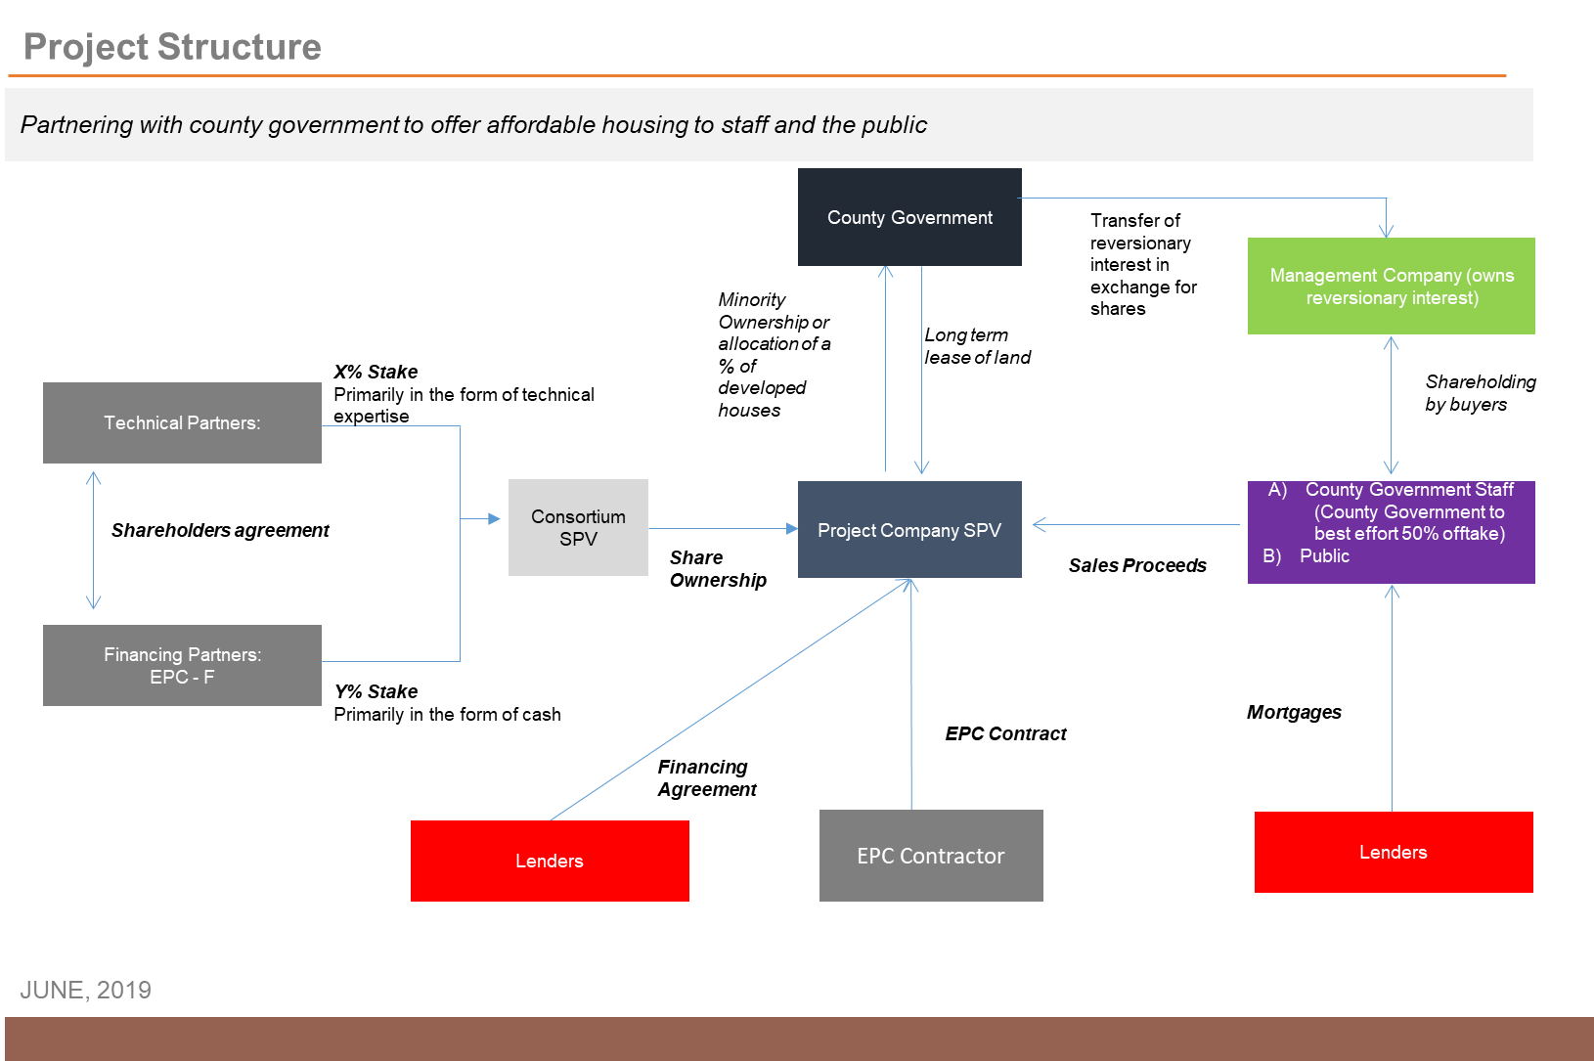

EXISTING TENANTS
Tudor Site

The site currently has a total of nine hundred (900) public rental houses comprising of 654 single rooms, 81 one-bed roomed units, 161 two-bed roomed units and 4 three-bed roomed units. There are fourteen (14) shops and one (1) social hall known as Tudor Social Hall within the site. There is no sufficient undeveloped open space where the Development Partner may commence the construction works of the new housing units. There may be need to develop in phases to minimize the need to move or relocate the existing tenants all at once. In the alternative, bidders may choose to provide in their bid price, relocation rent equivalent to the market rentals for similar units within the project site for a minimum period of 24 months which shall be paid as a lump sum to each tenant to relocate as the construction is undertaken. Those tenants who shall relocate to other houses will be given first priority to occupy the newly constructed and finished housing units. The relocation rent shall be negotiated between the County Government of Mombasa and the existing tenants, which aforesaid amount shall be based on the prevailing market rent rates on the estate being developed.

The County Government of Mombasa (CGM) shall have the cost of the housing units constructed for the existing Tenants deducted from its share of Allocated Housing Units as shall be agreed between the County and the Development Partner. These tenants will be expected to repay the County Government through an affordable Tenancy Purchase Scheme which will be equivalent to their current rent levels over a considerable duration of time.

MANAGEMENT COMPANY
The Development Partner will be required to register the Sectional Plans under the Sectional Properties Act No. 21 of 1987, or as amended, with the aim of dividing the buildings into units to be owned by individual proprietors and common property to be owned by proprietors of the units as Tenants in Common and to provide for the use and management of the units and common Property and for connected Purposes.

The Development Partner will facilitate the formation of a Management Company to be incorporated under the Sectional Properties Act which shall manage the property on behalf of all the purchasers. The Management Company shall consist of all those persons who are the owners of units in the parcel the Sectional Plan relates, and who are entitled to the parcel when the sectional arrangement is terminated under the Sectional Properties Act.

REPRESENTATIVES OF THE PARTIES

CONTRACTING AUTHORITY’S REPRESENTATIVE (S)
The Contracting Authority / CGM shall have the right to appoint one or more representative(s) to carry out the following:
- Inspect the performance of the Project in all its stages for the Contract duration; and
- Have authority to act on its behalf and issue binding decisions under this Contract within his / her given authority.

The CGM shall notify the Development Partner of the name(s) of CGM’s Representative(s) and their delegated authorities and powers.

The identity of the person or its replacement appointed by CGM to act as CGM’s Representative will be made in a separate written notification to the Development Partner Ten (10) days prior to their appointment or replacement.

DEVELOPMENT PARTNER’S REPRESENTATIVE (S)
The Development Partner shall have the right to appoint one or more representative(s) with the authority to act on its behalf and issue binding decisions under this Contract within his/her given authority. The Development Partner shall notify CGM of the name(s) of any Development Partner Representative(s) and their delegated authorities and powers. The identity of the person or its replacement appointed by Development Partner to act as Development Partner Representative shall be made in a separate written notification to CGM Ten (10) days prior to their appointment or replacement.

TUDOR ESTATE

Site Overview
The Site is approximately 21 acres. It is next to the Technical University of Mombasa. Tudor Estate is a water front area located in the island with a great potential for creation of a marina, due to the creek that Tudor Estate oversees. The estate has Acro and Romac type houses which are single rooms designed like Swahili houses. It is located along the Mombasa Road and can be accessed through Tom Mboya, Mombasa Road and Ronald Ngala Road.

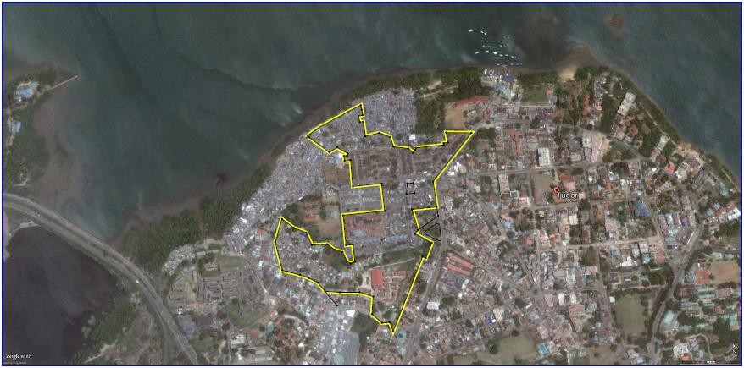
Source: Satellite Google Map

The existing development is composed of nine hundred (900) public rental houses, fourteen (14) shops and one (1) social hall.

The proposed redevelopment is to construct a minimum of 3, 920 modern and affordable housing units broken down as follows:
- Studio Apartments – 600 units
- One Bedroom – 760 units
- Two Bedroom – 1,664 units
- Three Bedroom – 896 units

Commercial Centres and other social amenities shall also be developed.

The Project shall integrate the following Planning Principles:

Densification: To ensure the highest and best use of land.

Compact Development: To optimize on land use, the Project is expected to adopt a vertical development approach.

Mixed Income Groups: The intended solution of the Project is to cater for different income groups.

Self-Reliance: The Project shall include support services such as playgrounds, schools or community halls.

Environmental Sustainability: The developers shall ensure the use of Green technology and energy conservation in developing the Project.

Human Centered Development: The proposed redevelopment shall take into account the needs of the residents and the larger public and as such, the designs of the units shall adequately address those needs.

SECTION II: INVITATION TO SUBMIT BID(S)
Bid No. CGM/PRO/T/001/2019-2020

Bid Name URBAN RENEWAL AND REDEVELOPMENT OF OLD ESTATES WITHIIN MOMBASA COUNTY THROUGH JOINT VENTURE PARTNERSHIP. LOT NO. 5 - TUDOR ESTATE

  - The County Government of Mombasa hereby invites Bids from eligible Bidders to undertake the Urban Renewal and Redevelopment of Tudor Estate within the County through a Joint Venture arrangement basis.
  - The Request for Proposal (RFP) includes the following documents: Section II Invitation to Submit Bid (s)
Section III Instructions to Bidders Section IV Project Output Specifications Section V Technical Proposal
Section VI Financial Proposal

Section VII General Outline of the Conditions of Contract

  - Bidders may obtain further information and inspect the Request for Proposal documents at the address given in the Appendix to Instructions to Bidders.
  - The Request for Proposal (RFP) document may be obtained free of charge between 0800 hours and 1600 hours on all working days from the County Procurement Department or the RFP document can also be downloaded from the official website of the National Treasury www.tenders.go.ke .
  - A complete set of Mandatory Requirements, Technical and Financial Bid documents should be submitted accompanied by a Bid Security of Kenya Shillings Ten Million (Kshs. 10,000,000) issued in favor of the Contracting Authority in the form of an unconditional and irrevocable bank guarantee issued by a Kenyan bank (or an internationally recognized bank) registered with the Central Bank of Kenya to be received on or before 30TH JULY 2019 at 1030 Hours East African Time. Failure to provide Bid Security will lead to automatic disqualification.

  - Completed Mandatory Requirements, Technical and Financial Bid documents shall be submitted in plain sealed envelopes clearly marked “BID NO. CGM/PRO/T/001/2019-2020 URBAN RENEWAL AND REDEVELOPMENT OF OLD ESTATES WITHIIN MOMBASA COUNTY THROUGH JOINT VENTURE PARTNERSHIP. LOT NO. 5 - TUDOR ESTATE” and marked “DO NOT OPEN BEFORE 30TH JULY 2019 at 1030 Hours.” and addressed to the Contracting Authority as per the Instructions to the Bidders.

  - Technical Bid documents will be opened thereafter at 1200 hours East African Time in the City Hall Committee Room, situated in the 1st Floor and bidders or their representatives are free to witness the opening if they so wish.
Yours Sincerely,

Director of Supply Chain Management, P.O. Box 80133 – 80100
MOMBASA.

SECTION III: INSTRUCTIONS TO BIDDERS

TABLE OF CONTENTS

Clause Numbers Description

A: GENERAL Page
  - Purpose of this Document 27
  - Eligibility and Qualification Requirements 27
  - Cost of Bidding 30
  - Site Visit 30

B: BID DOCUMENTS
  - Contents of Bid Documents 32
  - Inquiries by Bidders 32
  - Amendments of Bid Documents 33

C: PREPARATION OF BIDS
  - Language of Bid 34
  - Documents Comprising the Bid 34
  - Currencies of Bid 34
  - Bid Validity 34
  - Bid Security 35
  - Project Development Fee 37
  - No Alternative Offers 37

  - Format and Signing of Bids 38

D: SUBMISSION OF BIDS
  - Sealing and Marking of Bids 39
  - Deadline and Submission of Bids 40
  - Modification and Withdrawal of Bids 41

E: BID OPENING AND EVALUATION
  - Bid Opening 43
  - Process to be Confidential 44
  - Clarification of Bids 44
  - Determination of Responsiveness 45
  - Evaluation of Bids 46

F: AWARD OF CONTRACT
  - Award 50
  - Notification of award and Signing of Joint Venture Agreement 50
  - Performance Guarantee 52
  - Corrupt or Fraudulent Practices 52
  - Appendix to Instructions to Bidders 52

A GENERAL

  - Purpose of this Document
This RFP issued to Bidders is to provide instructions and regulations regarding the preparation, submission and the evaluation of Bids.

Eligibility and Qualification Requirements
    - Mandatory Requirements

Bidders are Reminded To Take Note that only bids meeting the following mandatory requirements will be evaluated.
The following are mandatory requirements;

      - Bid Security for the Project in accordance with Annex A (Appendix to Instructions to Bidders) and Standard Form IX.
      - A covering letter in accordance with Standard Form I.

      - The Bidders Information Sheet in Accordance with Standard Form II.
      - In case of a Bidding Consortium (BC), the Power of Attorney for designating the Lead Consortium Member in accordance with Standard Form V.
      - Power of Attorney to the Bid Signatory in accordance with Standard Form VI.
      - The Certificate of Bidder’s visit to site in accordance with Standard Form IV.
      - Format of undertaking in accordance with Standard Form VII.

      - In case of a Bidding Consortium (BC), the Joint Bidding Agreement in accordance with Standard Form VIII.

      - The requisite number of copies of Bid documents as stipulated in the RFP.

      - Proof of financial ability in the form of a bank guarantee for KES 50, 000, 000.00 (Kenya Shillings Fifty Million Only), which sum shall be utilized for all preliminary project costs including relocation of any existing tenants. The aforesaid sum shall be availed to the County Government of Mombasa within 30 days of the award of the tender, failure to which the County Government of Mombasa shall cancel the tender so awarded.

Eligibility Criteria
      - Bidders must prove that they have undertaken project(s) of similar nature on a JV, single Entity or any other partnership agreements (Enclose copy of agreement with the client, which clearly mentions the total contract value of project or Completion Certificate from the client for the development).

      - Demonstrate the ability to put together a project management team to deliver the project within a maximum period of 24 months. (Provide CV’s and Certificates, both professional and educational, of key personnel to be involved in the project and their roles).

      - Bidders shall demonstrate ability to raise equity for deployment to the development of the Project to the extent of USD 30 Million. In case of consortium, the Bidder has to demonstrate the ability of each member’s contributions towards the above amount and indicate the equity available for deployment towards the project. (Bidders to attach audited accounts for the last three (3) Years).

      - Demonstrate capacity and ability to raise debt funding to the tune of USD 60 Million besides the minimum equity contribution stated in item (c) above. (Bidders to attach a letter from the Lender expressing interest to support the Project).

      - Demonstrate ability to arrange competitive end buyer Mortgage schemes.

      - The CGM’s officials, representatives, employees, and their relatives (spouse and children) are not eligible to participate in the bid.

Bidding Consortium (BC)

Bids submitted by a Bidding Consortium shall comply with the following requirements;
        - The Joint Bidding Agreement entered into by the bidding consortium parties in the format outlined in Standard Form VIII shall be submitted with the bid.
        - One of the Party shall be nominated to be the Lead Consortium Member and shall be authorized to give and receive instructions for and on behalf of any and all the partners of the joint venture, and the execution of the contract;
        - All parties of the Bidding consortium shall be liable jointly and severally for the execution of the contract in accordance with the contract terms.

Constituent Parts of the Mandatory Requirements
Bidders who shall fail to provide all of the requisite mandatory requirements will have their bids considered unresponsive and subsequently disqualified.

Falsified information
A Bidder who gives false information in the bid document about their qualification, or who refuses to enter into a contract after notification of award of contract shall be considered for debarment from participating in future public procurement.

Cost of Bidding
    - The Bidder shall bear all costs associated with the preparation and submission of its bid and of negotiating the Contract including any visit to the Sites. CGM will in no case be liable for those costs, regardless of the conduct or outcome of the bidding process.

Site Visit
    - The Bidder is advised to visit and examine the sites and their surrounding and obtain for itself at its own cost and responsibility, all information that may be necessary for preparing the bid(s) and entering into a contract.

    - The Bidder and any of its personnel or agents will be granted permission by CGM to access the land for the purpose of such visit, but only upon the express condition that the Bidder, its personnel or agents, will release and indemnify CGM from and against all liability in respect of and will be responsible for personal injury (whether fatal or otherwise), loss of or damage to property and any other loss, damage, costs and expenses however caused, which but for the exercise of such permission, would not have arisen.

    - CGM shall organize site visits at certain dates as indicated in the Appendix to Instructions to Bidders. A representative of CGM will be available to meet the visiting Bidders at the sites. The representative(s) will not be available at any other time for site inspection visits. Bidders must provide their own transport.

B BID DOCUMENTS

  - Contents of Bid Documents
    - The bid documents comprise the documents listed here below and are to be read together with any addendum issued in accordance with Clause 3.7 of these Instructions to Bidders. The bid document consists of six (6) main parts, namely:-

SECTION II “INVITATION TO SUBMIT BID (S)” SECTION III “INSTRUCTIONS TO BIDDERS” SECTION IV “PROJECT OUTPUT SPECIFICATIONS” SECTION V “TECHNICAL PROPOSAL”
SECTION VI “FINANCIAL PROPOSAL”

SECTION VII “GENERAL OUTLINE OF THE CONDITIONS OF CONTRACT”

    - The Bidder is expected to examine carefully all instructions, conditions and forms in the bid document. Failure to comply with the requirements for bid submission will be at the Bidder’s risk. Pursuant to Clauses 3.2.1, 3.2.2 & 3.2.3 of Instructions to Bidders, bids which are not responsive to the requirements of the bid documents will be rejected.

    - All recipients of documents related to this bid for the purpose of submitting a bid (whether they submit a bid or not) shall treat the details of the documents as “Private and Confidential”.

Inquiries by Bidders:
    - A Bidder making an inquiry relating to the bid documents may

notify CGM in writing by fax or email at CGM’s mailing address indicated in the invitation to submit bid(s). CGM will respond in writing to any request for clarification which is received earlier than seven (7) days prior to the deadline for the submission of bids. Written copies of CGM’s response (including the inquiry but without identifying the source of the entity) will be sent to all Bidders who have been invited to bid. If a Bidder sends an inquiry after the stated days, CGM shall have the option of either responding to the inquiry and extension of the date of submission of bids or ignoring it.

    - CGM shall reply to any clarifications sought by the Bidder within three (3) days of receiving the request to enable the Bidder to make timely submission of its bid(s).

Amendment of Bid Documents
    - At any time prior to the deadline for submission of bids, CGM may, for any reason, whether at its own initiative or in response to a clarification requested by a Bidder, modify the bid documents by issuing an addendum.

    - Any addendum will be notified in writing, or by facsimile, telephone or email mailing address indicated in the bid submission to all prospective Bidders who have been invited to bid and will be binding upon them.
    - In order to allow prospective Bidders reasonable time in which to take the addendum into account in preparing their bids, CGM may, at its discretion, extend the deadline for the submission of bids.

Language of the Bid:
    - The bid and all correspondence and documents relating to the bid exchanged between the Bidder and CGM shall be written in the English language. Supporting documents and printed literature furnished by the Bidder with the bid may be in another language provided they are accompanied by an appropriate translation of pertinent passages in the above stated language. For the purpose of interpretation of the bid, the English language shall prevail.

Documents Comprising the Bid:
    - The Forms submitted with the bid documents shall be used without exception subject to extensions of the schedules in the same format and to the provisions of Clause 3.14.2 regarding the alternative forms of bid security.

Currencies of the Bid:
    - The currency for the purpose of the Bid shall be Kenya Shillings (Kshs). The conversion of foreign currency to Kenya Shillings shall be based on the corresponding Exchange rate specified by the Central Bank of Kenya, on the closing date of bid submission.

Bid Validity:
    - The bid shall remain valid and open for acceptance for a period of Ninety(90) days from the date of Bid opening or from the extended date of Bid opening.

    - In exceptional circumstances prior to expiry of the original bid

validity period, CGM may request Bidders for a specified extension of the period of bid validity. The request and the responses thereto shall be made in writing or by email or facsimile. A Bidder may refuse the request without forfeiting the Bid Bond. A Bidder agreeing to the request will not be required nor permitted to modify its bid, but will be required to extend the validity of the Bid Bond correspondingly.

Bid Security:
    - As part of its bid, the Bidder shall furnish to CGM a Bid Security of Kenya Shillings Ten Million (Kshs. 10,000,000) from an established and reputable bank approved by CGM and located in the Republic of Kenya or an internationally recognized bank by the Central Bank of Kenya.

    - The Bid Security shall be valid for at least One Hundred and Twenty (120) days from the date of Bid opening or from the extended date of Bid opening.

    - Any Bid not accompanied by the requisite Bid Security as per clause 3.12.1 will be rejected by CGM as non-responsive.

    - The Bid Securities of unsuccessful Bidders will be returned as promptly as possible but not later than twenty eight (28) days after concluding the Contract execution and after a Performance Security has been furnished by the Successful Bidder to CGM. The Bid security of the Successful Bidder will be returned upon the Bidder executing the Contract and furnishing CGM with the required Performance Security.

    - CGM shall reserve the right to forfeit the Bid Security under the following circumstances:
      - If the Bidder withdraws its Bid at any time during the stipulated period of Bid validity (or as may be extended).
      - If the Bidder, for the period of Bid Validity, in CGM’s opinion, commits material breach of any of the terms and / or conditions contained in the RFP Document and / or subsequent communication from CGM in this regard.
      - In the case of a Successful Bidder, if he fails:

        - To accept the Letter of Acceptance, or

        - To sign the Agreement, or

        - To furnish the necessary Performance Security.

    - In the event that the bid is declared non-responsive, the Bid Security in such cases shall be returned to the respective Bidder within 30 days from such cessation without interest.

    - The Bid Security of the unsuccessful Bidders will be returned after 30 days without any interest, following the signing of the Joint Venture Agreement by the Successful Bidder.

    - The Bid Security of the Successful Bidder shall be required to be maintained till the signing of the Joint Venture Agreement.

(A) Consultants fee
The Bidders shall include as part of their Financial Bids, an amount equivalent to 8% of the Total Project Development Cost as Consultants fees to be paid to the design team engaged by the Contracting Authority for the preparation of Architectural and Engineering drawings and other necessary project documents. The Successful Bidder may negotiate the Consultants fee and enter into separate service contracts with members of the design team before commencement of the construction.

(B) Project Development Fee:

The Bidders shall also include as part of their Financial Bids, an amount equivalent to 1.75% of the Total Project Development Cost as Project Development Fee to be paid to the Transaction Advisors for the Project. The Project Development fee is to be paid by the Development Partner within Thirty (30) days upon execution of the Joint Venture Agreement.

No Alternative Offers:
    - The Bidder shall submit an offer which complies fully with the requirements of the bid documents unless otherwise provided for in the Appendix to instructions to Bidders. Only one bid may be submitted by each Bidder either by itself or as a member in a bidding consortium.

    - The Bidder shall not attach any conditions of its own to its bid. Any Bidder who fails to comply with this Clause will have its bid declared non responsive and will be disqualified.

Format and Signing of Bid
    - The Bidder shall prepare the bid as outlined in Clause 3.17 and mark appropriately one set “ORIGINAL” and the other “COPY”.

    - The copy of the bid shall be typed or written in indelible ink and shall be signed by a person or persons duly authorized to sign on behalf of the Bidder. All pages of the bid where amendments have been made shall be initialed by the person or persons signing the bid.

    - The complete bid shall be without alterations, interlineations or erasures, except as necessary to correct errors made by the bid, in which case such corrections shall be initialed by the person or persons signing the bid.

SUBMISSION OF BIDS

  - Sealing and Marking of Bids
    - The Bidder shall place one (1) original plus three (3) copies of their Mandatory Requirements in a sealed envelope clearly marked “MANDATORY REQUIREMENTS”. The Bidder shall clearly mark the original document as “ORIGINAL” and the 3 copies as “COPY”.

The Bidder shall place one (1) original plus three (3) copies of their Technical Proposal in a sealed envelope clearly marked “TECHNICAL PROPOSAL”. The Bidder shall clearly mark the original document as “ORIGINAL” and the 3 copies as “COPY”.

The Bidder shall place one (1) original of its Financial Proposal in a sealed envelope clearly marked “FINANCIAL PROPOSAL”. The Bidder shall clearly mark the original document as “ORIGINAL”. No copies are allowed for the Financial Proposal.
The Bidder shall also a place a soft copy of its Bid in a CD-ROM and clearly marked “URBAN RENEWAL AND REDEVELOPMENT OF OLD ESTATES WITHIN MOMBASA COUNTY THROUGH JOINT VENTURE PARTNERSHIP. LOT NO. 5 – TUDOR ESTATE”.

In the event of discrepancy between the original and any copy, the original shall prevail.

The three envelopes should then be sealed in one common outer envelope marked “BID NO: CGM/PRO/T/001/2019-2020

URBAN RENEWAL AND REDEVELOPMENT OF OLD ESTATES WITHIN MOMBASA COUNTY THROUGH JOINT VENTURE PARTNERSHIP. LOT NO. 5 - TUDOR ESTATE”.

    - The inner and outer envelopes shall be addressed to CGM at the address stated in the Appendix to Instructions to Bidders and bear the name and identification of the Contract stated in the said Appendix with a warning not to open before the date and time for opening of bids as stated in the said Appendix.

    - The inner envelopes shall each indicate the name and address of the Bidder to enable the bid to be returned unopened in case it is declared “late”, while the outer envelope shall bear no mark indicating the identity of the Bidder.

    - If the outer envelope is not sealed and marked as instructed above, CGM will assume no responsibility for the misplacement or premature opening of the bid. A bid opened prematurely for this cause will be rejected by CGM and returned to the respective Bidder.

Deadline for Submission of Bids
    - Bids must be received by CGM at the address specified in the Instructions to Bidders and on the date and time specified in the Invitation to Submit Bid(s).

Bids delivered by hand must be placed in the Bid Box located on the 2nd Floor at the Office of the Director of Supply Chain Management, Room 210 so as to be received not later than

…………………. at 1030 Hours East African Time (G.M.T.
+3).

Proof of posting will not be accepted as proof of delivery and any bid delivered after the above stipulated time, from whatever cause arising will not be considered.

Bulky bids which cannot be placed in the Bid box will be received by CGM on 2nd Floor at the Office of the Director of Supply Chain Management, Room 210. Ensure that the documents are officially received before closing time and entered into the register for inclusion during Bid opening.

    - CGM may at its discretion, extend the deadline for the submission of bids through the issue of an Addendum in accordance with Clause 3.7 of the Instruction to Bidders, in which case all rights and obligations of CGM and the Bidders previously subject to the original deadline shall thereafter be subjected to the new deadline as extended. The Addendum will be posted in CGM’s official website immediately upon issuance.

    - Any bid received by CGM after the prescribed deadline for submission of bids will be returned unopened.

Modification and Withdrawal of Bids
    - The Bidder may modify or withdraw its bid after bid submission, provided that written notice of the modification or withdrawal is received by CGM prior to the prescribed deadline for
submission of bids.

    - The Bidder’s modification or withdrawal notice shall be prepared, sealed, marked and dispatched in accordance with the provisions for the submission of bids, with the inner and outer envelopes additionally marked “MODIFICATION” or “WITHDRAWAL” as appropriate.

    - No bid may be modified subsequent to the deadline for submission of bids.

    - No bid may be withdrawn in the interval between the deadline for submission of bids and the period of bid validity specified on the bid form. Withdrawal of a bid during this interval will result in the forfeiture of the Bid Surety.

    - Subsequent to the expiry of the bid validity period prescribed by CGM, and the Bidder having not been notified by CGM of the award of the Contract or the Bidder does not intend to conform with the request of CGM to extend the period of bid validity, the Bidder may withdraw its bid without risk of forfeiture of the Bid Bond.

BID OPENING AND EVALUATION

  - Bid Opening
    - CGM will open the outer envelope and the inner envelopes containing the “MANDATORY REQUIREMENTS” & “TECHNICAL PROPOSAL” in the presence of the Bidders’ Representatives who choose to attend at the time and location indicated in the Invitation to Bid. The Bidders’ representatives who are present shall sign a register evidencing their attendance.

    - Bids for which an acceptable notice of withdrawal has been submitted, pursuant to Clause 3.18 will not be opened. CGM will examine the bids to determine whether they are complete, whether the requisite Bid Securities have been furnished, whether the documents have been properly signed and whether the bids are generally in order.

    - At the bid opening, CGM will announce the Bidder’s names, the presence of the requisite Bid Security and such other details as CGM, at its discretion, may consider appropriate. No bid shall be rejected at the bid opening except for late bids.

    - CGM shall prepare minutes of the bid opening including the information disclosed to those present.

    - Bids not opened and read out at the bid opening SHALL NOT be considered for further evaluation, irrespective of the circumstances. Any bid recited after the deadline for submission of bid shall be returned to the Bidder unopened.

Process to be Confidential
    - After the public opening of bids, information relating to the examination, clarification, evaluation and comparisons of bids and recommendations concerning the award of Contract shall not be disclosed to Bidders or other persons not officially concerned with such process until the award of Contract is announced.

    - Any effort by a Bidder to influence CGM in the process of examination, evaluation and comparison of bids and decisions concerning award of Contract may result in the rejection of the Bidder’s bid.

Clarification of Bids
    - To assist in the examination, evaluation and comparison of bids, CGM may ask Bidders individually for clarification of their bids. The request for clarification and the response shall be in writing or by facsimile or telex, but no change in the price or substance of the bid shall be sought, offered or permitted EXCEPT as required to confirm the correction of arithmetical errors discovered by CGM during the evaluation of the bid.

    - No Bidder shall contact CGM on any matter relating to its bid from the time of the bid opening to the time the Contract is awarded. If the Bidder wishes to bring additional information to the notice of CGM, it shall do so in writing.

Determination of Responsiveness

    - Prior to the detailed evaluation of bids, CGM will determine whether each bid is responsive to the requirements of the bid documents. A bid may be deemed non-responsive if it does not satisfy any of the following conditions:
      - It does not meet the mandatory requirements.

      - It does not contain sufficient information for it to be evaluated and / or is not in the specific formats.
      - It is not signed and / or sealed in the manner and to the extent indicated in Section 3.16 of this RFP.

    - For the purpose of this clause, a responsive bid is one which conforms to all the preceding terms, conditions and specification of the bid documents without material deviation or reservation. A material deviation or reservation is one which affects in any substantial way the scope, quality, or performance of the contract, or which limits in any way inconsistent with the bid documents, CGM’s rights or the Bidder’s obligations under the Contract and the rectification of which would affect unfairly the competitive position of other Bidders who have presented responsive bids.

    - A bid determined not to be responsive will be rejected by CGM and may not subsequently be made responsive by the Bidder by correction of the non-conforming deviation or reservation.

Evaluation of Bids
    - CGM will only evaluate bids determined to be responsive to the requirements of the bid documents in accordance with Clause 3.2.
Responsive Bids will be evaluated in the following steps;

Step 1: Evaluation of Mandatory Requirements

Evaluation of Mandatory Requirements will be assessed. The Bidder will be expected to meet the minimum eligibility in accordance with Clause 3.2.1.

The Bidders should furnish all information required. Any Bidder found not to have met the mandatory requirements will be declared to be non- responsive and shall not be eligible for the next stage of the evaluation process.

The “TECHNICAL PROPOSAL” and “FINANCIAL
PROPOSAL” of such Bidders shall be returned unopened.

Only those Bidders who pass the mandatory requirements evaluation stage will proceed to the next stage of technical evaluation.

Step 2: Evaluation of Technical Proposal

In this stage the Bidders’ technical proposals will be assessed. The Bidders should furnish all the information required to support their technical proposal.

The evaluation shall be done by the Evaluation Committee in accordance with Clause 3.2.1, 3.2.2 & 3.2.3 of the Instructions to Bidders and the Standard Forms contained in this RFP. Technical Proposals will be assessed in accordance with the following parameters:
      - Use of appropriate Construction Technology and Programme of Works.
      - Conformity of the Construction Technology and approach to applicable laws and regulations;
      - Demonstration of the overall site management strategy to limit disruption to existing tenants during construction;
      - Adherence to the planning principles outlined in the RFP;

Bidders who shall not pass the technical evaluation stage will have been found to be technically incapable and shall not be eligible for the next stage of the evaluation process. Their Financial Proposals shall be returned unopened.

A technical score (TS) shall be awarded to each evaluated Bidder as per the evaluation criteria and those who will have attained the required cut off marks at the technical evaluation stage will have their technical bids declared successful . All such Bidders shall be eligible for the next stage of financial evaluation.

Step 3: Evaluation of Financial Proposal

In this stage the Bidders’ Financial Proposals will be assessed in accordance with the following parameters:

- Cost of development of individual units (Studio Apartments, 1 BR, 2 BR & 3 BR);
- Overall development cost

- Proposed mortgage facility / Tenant Purchase Scheme to be offered by the Developer to end buyers;
- Elaborate marketing strategy for selling the developed units.

A Financial Score (FS) shall be awarded to each evaluated Bidder. The final score for each Bidder shall be arrived at by aggregating the Technical and Financial scores.

    - The bid evaluation committee shall evaluate the financial bids within 30 days from the date of notification of the results of the technical evaluation.

    - CGM may at any time terminate procurement proceedings before award and shall not be liable to any person for the termination.

    - CGM shall give prompt notice of the termination to the Bidders and on request give its reasons for termination within 14 days of receiving the request from any Bidder.

    - Persons not officially involved in the evaluation of the bids shall not attempt in any way to influence the evaluation.

    - Any person who has a conflict of interest with respect to the

procurement shall not participate in the procurement proceedings.

AWARD OF CONTRACT

  - Award
    - Subject to Clause 3.26, CGM will award the bid and enter into a Joint Venture Agreement with the Development Partner:
      - Whose bid is determined to be responsive to the bid documents, and
      - Who has been assessed as being technically and financially capable, and
      - Who has attained the highest aggregated score in the TECHNICAL and FINANCIAL evaluation.

    - CGM reserves the right to accept or reject any bid, and to annul the bidding process and reject all bids, at any time prior to award of Contract, without thereby incurring any liability to the affected Bidders or any obligation to inform the affected Bidders of the grounds for CGM’s action.

Notification of Award and Signing of the Joint Venture Agreement

    - Prior to the expiry of the bid validity period prescribed by CGM, CGM will issue the Successful Bidder by email and confirmed in writing by registered letter that its Bid has been accepted. This letter hereinafter and in all contract documents shall be called the “Letter of Acceptance”.

    - Within fourteen (14) days of receipt of the Letter of Acceptance from CGM, the Successful Bidder shall send a written

acknowledgement agreeing to comply with the conditions set out therein and for the execution of the development contract. This notification of award will constitute the formation of the Contract subject to the parties signing the Joint Venture Agreement.

    - The Successful Bidder shall sign the Joint Venture Agreement from CGM within twenty eight (28) days from the date of receipt of the Joint Venture Agreement and return it to CGM together with the requisite Performance Security.

    - Upon the furnishing of the Performance Security by the Successful Bidder to CGM, CGM will promptly notify other Bidders that their proposals have been unsuccessful and their bid security will be returned within 30 days without interest upon signing of the Joint Venture Agreement with the Successful Bidder.

    - The parties to the Joint Venture Agreement shall have it signed within thirty (30) days from the date of notification of contract award unless there is an administrative review request.

    - In the absence of an administrative review request, failure of the Successful Bidder to enter into a Joint Venture Agreement within the stipulated period shall constitute sufficient grounds for the annulment of the Letter of Acceptance (LOA) and forfeiture of the bid security. In such event, CGM reserves the right to invite the second best evaluated Bidder for negotiations, or call for fresh Bids OR take any such measures as may be deemed

fit in the sole discretion of CGM including annulment of the bidding process.

Performance Guarantee
    - Within twenty eight (28) days of receipt of the notification of award from CGM, the Successful Bidder shall furnish CGM with a Performance Security in an amount stated in the Appendix to Instructions to Bidders.

    - The Performance Security to be provided by the Successful Bidder shall be an unconditional Bank Guarantee issued at the Successful Bidder’s option by an established and reputable Bank approved by CGM and located in the Republic of Kenya or an internationally recognized bank approved by CGM.

Corrupt or Fraudulent Practices:
CGM requires that Bidders observe the highest standards of ethics during the procurement process and execution of contract. A Bidder shall sign a declaration form that it has not and will not be involved in any corrupt and fraudulent practices. Any Bidder that shall be involved in corrupt or fraudulent practices will be disqualified from the procurement process and shall be guilty of an offence under the Public Procurement and Disposal Act Chapter 412C of the Laws of Kenya.

Appendix to Instructions to Bidders:
The following information regarding the particulars of the bid shall complement, supplement or amend the provisions of the Instructions to Bidders. Whenever there is a conflict between

the provisions of the Instructions to Bidders and the provisions of the appendix, the provisions of the appendix herein shall prevail over those of the Instructions to Bidders.

ANNEX A - APPENDIX TO INSTRUCTIONS TO BIDDERS

1. | PROJECT NAME | Urban Renewal and Redevelopment of Old Estates within Mombasa County through Joint Venture Partnership. Lot No. 5 - Tudor Estate. Bid No: CGM/PRO/T/001/2019-2020
2. | CONTRACTING AUTHORITY | County Government of Mombasa (CGM)
3. | ADDRESS FOR SUBMISSION OF BIDS | Office of the Director of Supply Chain Management  County Government of Mombasa 2nd Floor, Room 201  P.O. Box 80133 – 80100  Mombasa, Kenya.
4. | BID SUBMISSION DEADLINE, LOCATION OF MANDATORY REQUIREMENTS AND TECHNICAL BIDS ENVELOPES OPENING | Bid Submission Deadline will be on CGM/PRO/T/001/2019-2020 at 1030 Hours, East African Time, which will be the date on which the Bid Opening Committee convenes to open Mandatory Requirements and Technical Bids Envelopes.  Location: Office of the Director of Supply Chain Management, 2nd Floor, Room 201, Mombasa, Kenya.
5. | LOCATION, TIME AND DATE FOR FINANCIAL BIDS ENVELOPES OPENING | All Bidders whose Technical Bids will have passed the Technical Evaluation as per the evaluation criteria, will be notified in writing, of the time, date, and venue of the Financial Bid Envelopes opening.

Site / Estate | Bid Security (Kshs)
Tudor Estate | 10,000,000

6. | BID CURRENCY | Kenya Shillings (Kshs.)
7. | LANGUAGE OF BID | All Bids, correspondence and documents required under or related to the Bid Process shall be made in the English language. Bidders may submit Bids, correspondence and documents in any other language, provided that the same are accompanied by an English translation duly signed by the Authorized Representative of the Bidder. In case of discrepancy between the other language and English texts, the English text shall prevail.
8. | BID VALIDITY PERIOD | Submitted Bids shall remain effective for Ninety (90) Days from and including the date of the Bid Submission Deadline.
9. | AMOUNT OF BID SECURITY | Bidders shall furnish to CGM a Bid Security of Kenya Shillings Ten Million (Kshs. 10,000,000) from an established and reputable bank approved by the Central Bank of Kenya Ltd or an internationally recognized bank.  Value of Bid Security
10. | PERFORMANCE SECURITY | Within Twenty Eight (28) Days of receipt of the  Notification of Award from CGM, the Successful Bidder shall furnish to CGM with a

 |  | Performance Security equivalent to 10% of the Contract Price issued by an established and reputable bank approved By Central Bank of Kenya and located in the Republic of Kenya or an internationally recognized bank.
11. | NUMBER OF COPIES OF THE BID | Bids shall be made in three envelopes: the first containing the “MANDATORY REQUIREMENTS”, the second containing the “TECHNICAL PROPOSAL”, and the third containing the “FINANCIAL PROPOSAL”  labeled and sealed as illustrated below:-
 |  | Envelope “A”
 |  | Contain one (1) original and three (3) copies of the Mandatory Requirements.
 |  | Envelope “B”
 |  | Contain one (1) original and three (3) copies of the Technical Proposal.
 |  | Envelope “C”
 |  | Contain one (1) original of the Financial Proposal.
 |  | All to be sealed in a plain outer envelope clearly marked as in note ‘1’ above.
12. | SITE VISIT | A site visit shall be conducted on the day of 22ND JULY 2019 from 0900 Hours to 1400 Hours.

SECTION IV: PROJECT OUTPUT SPECIFICATIONS

Architectural Concept Designs
The Concept designs for the Project have been prepared to ensure that the housing units provide modest, self-contained accommodation of suitable space and size in order to meet household needs. Bidders should ensure adherence to the project designs including unit sizes, features, and amenities in accordance with the Project Output Specifications in the RFP Document.

The Project should utilize green technologies that promote the conservation of non-renewable resources, minimize environmental impact, and/or include building components that contribute to the economic efficiency of the facility over the long term.

The development shall comprise construction of residential units of various types and configuration with all the attendant social amenities to support the Estate.
- The Estate should comprise of Studio Apartments, one bed roomed, two bed roomed and three bed roomed housing units.
- Bidders are to include innovative and green building solutions.
- Bidders are to ensure that 60 % (Sixty Percent) of the housing units are in the range of affordable housing.

THE ARCHITECTURAL CONCEPT DESIGNS
Highlights of the Tudor Estate Design
  - It will be a Middle to Low Income Modern Residential Development
  - Responds to site and the neighbourhood
  - Maximizes Lettable area
  - Provided Modern Facilities
  - Parking Area/Vehicular access/Vehicular Circulation
  - Offers facilities for the Disabled
  - Promotes Energy Efficiency
  - Incorporates Disaster Management Solutions

TUDOR ESTATE MASTERPLAN
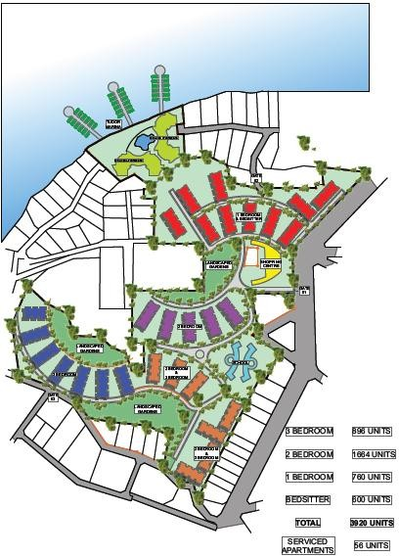

STUDIO APARTMENTS AND ONE BEDROOM FLOOR PLAN LAYOUT
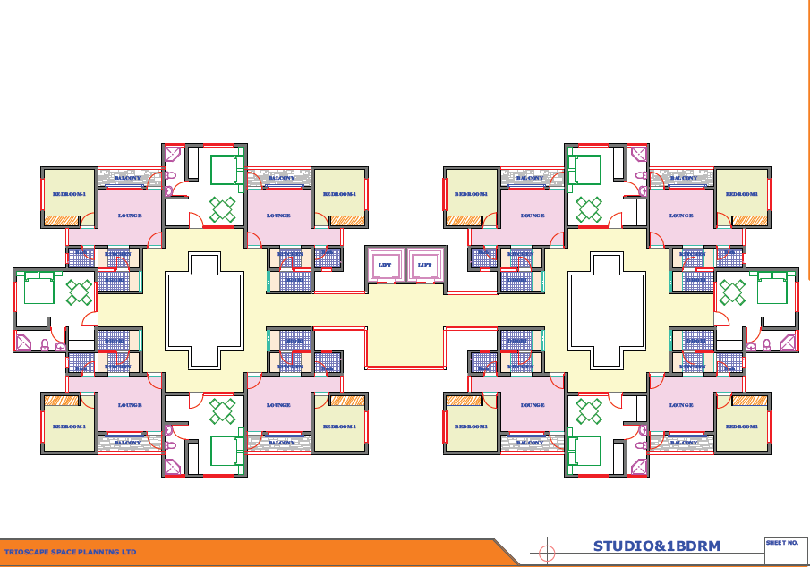

ONE BEDROOM TOP VIEW IMAGE
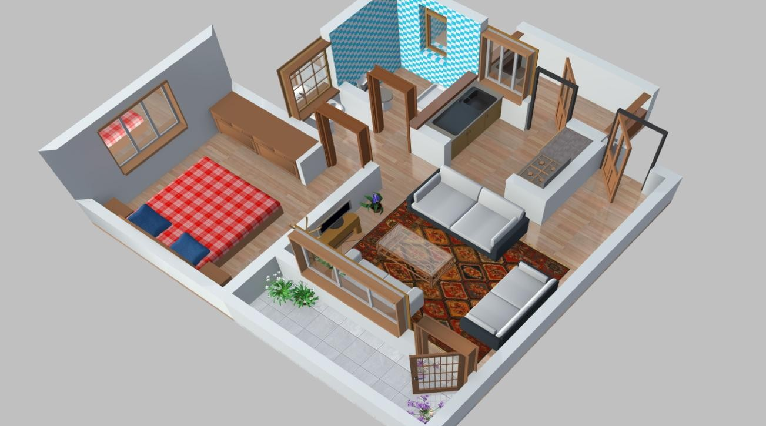

TWO AND THREE BEDROOM FLOOR PLAN LAYOUT

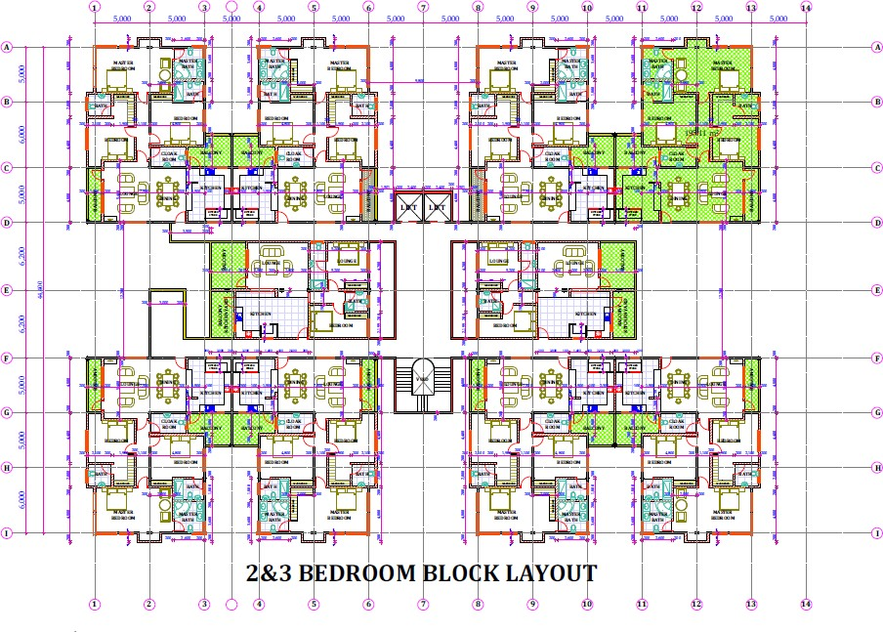

TWO AND THREE BEDROOM BLOCK PERSPECTIVE IMAGE
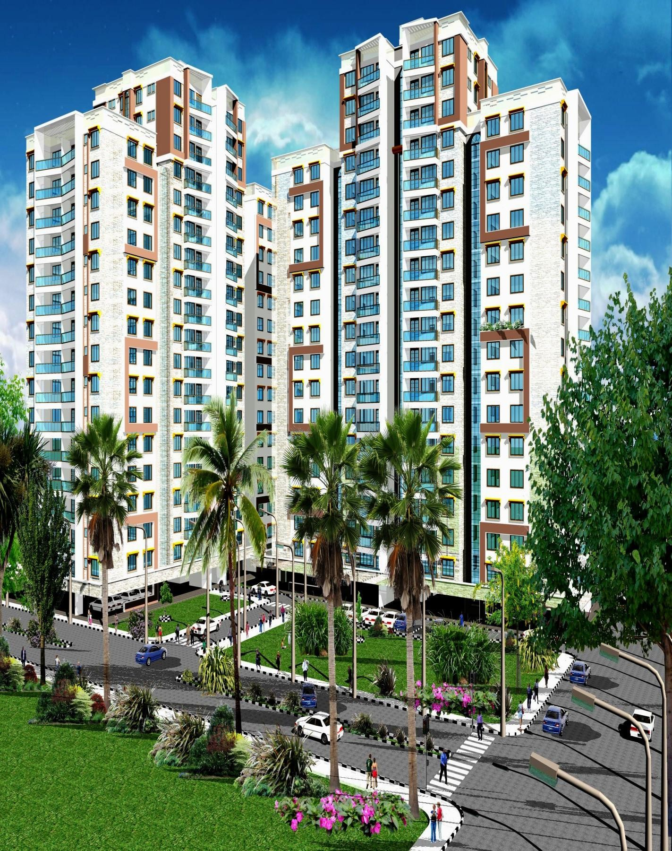

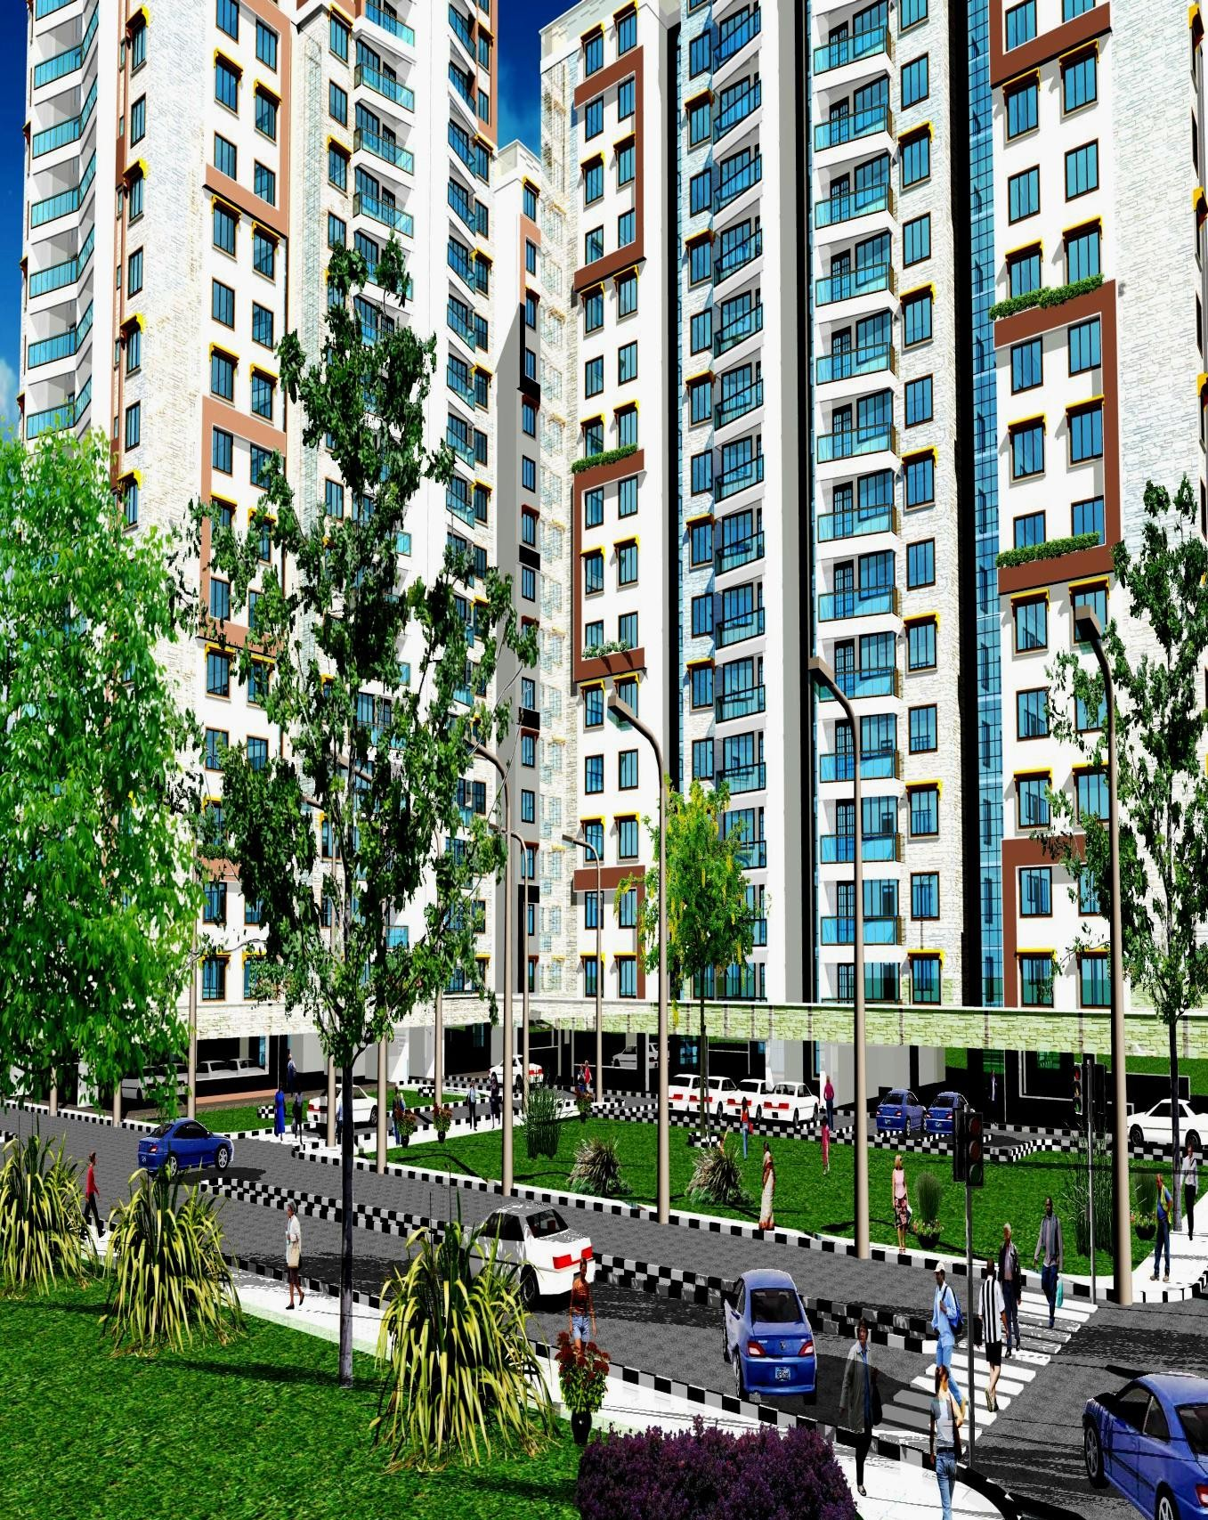

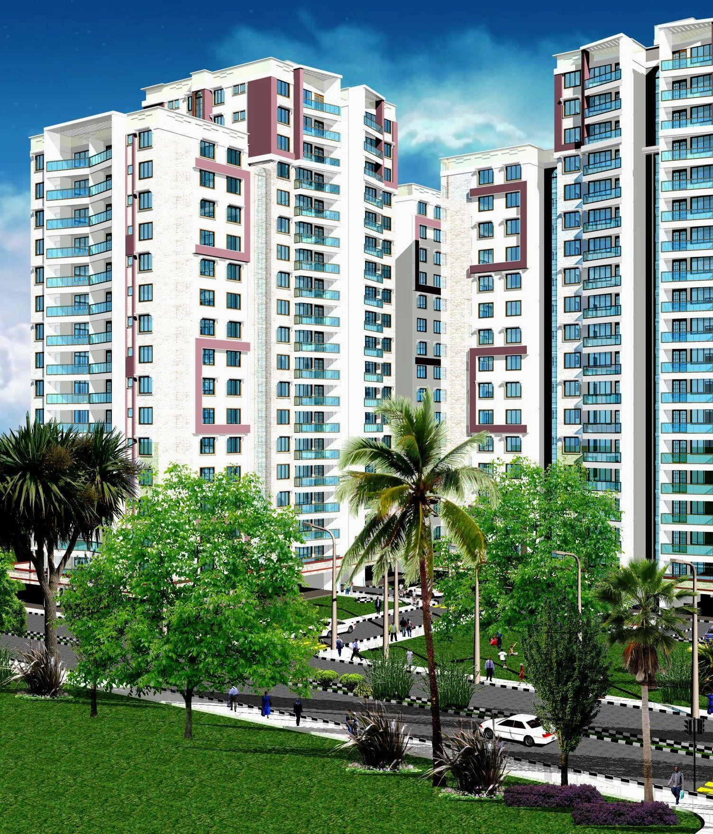

66

THREE BEDROOM TOP VIEW IMAGE
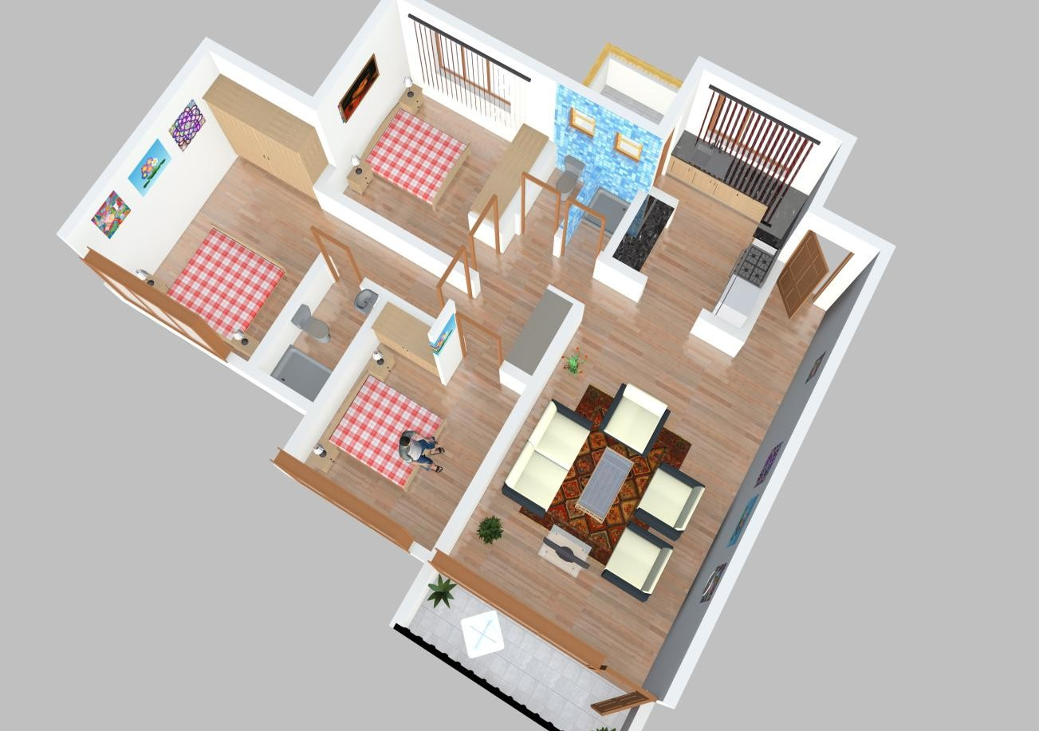

MARINA BLOCK LAYOUT

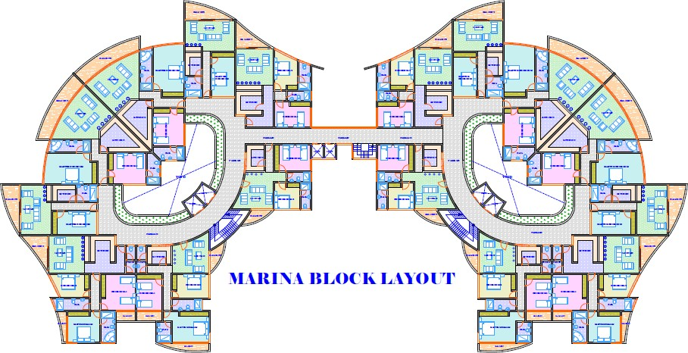

MARINA BLOCK PERSPECTIVE IMAGE
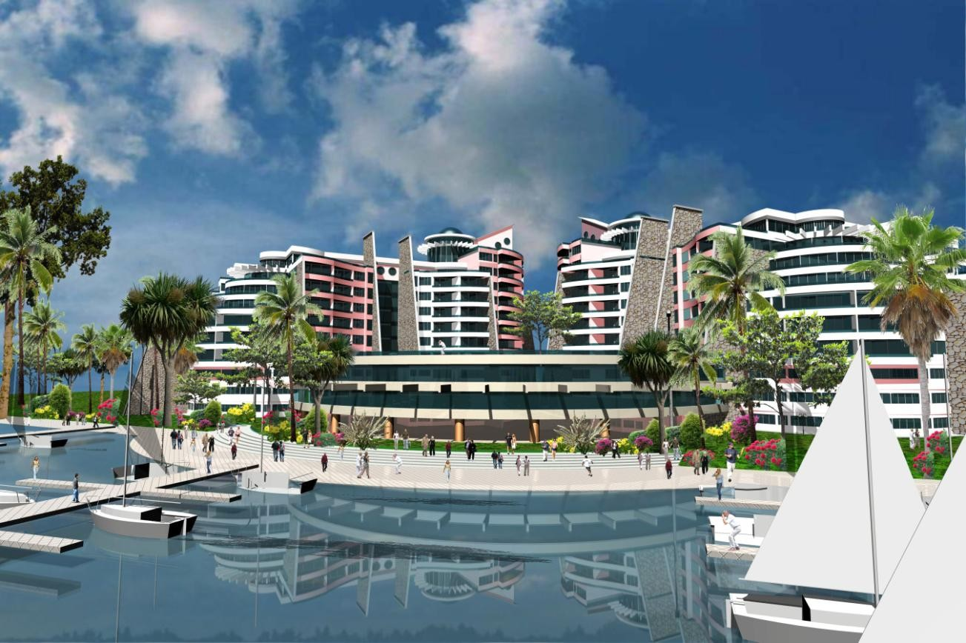

Particulars of the proposed housing units are as stated in the table below:

Unit Type | Minimum Unit Area | No. of Units
Studio Apartments | 40 sqm | 600
1 Bedroom | 60 sqm | 760
2 Bedroom | 85 sqm | 1,664
3 Bedroom | 104 sqm | 896

NB:

- Units of different sizes will be considered on condition that they are consistent generally with similar unit sizes for rental properties within the same geographical area as the site.
- Floor areas for units designed for an individual living with a disability may exceed the minimum unit sizes provided they are consistent with Affordable Rents for that geographical area, to accommodate mobility requirements.

Modesty Standards

- Notwithstanding the unit sizes provided, projects should generally reflect modest accommodation.
Communal Facilities (preferable modern integrated models)

- Recreational and playing fields.

- Open Grounds.

- Social Halls.

- Commercial Centre.

Roads

- The Development to have a properly designated network of primary distributor roads, local distributor roads, major and minor access roads and footpaths.
- Roads to have storm water drainage and a pedestrian pavement on at least one side.
- Roads to have street and footpath lighting.

Other preferred community facilities which may be considered

- Storm water, boreholes and roof harvesting facilities to complement normal water supply.
- Use of renewal energy and solar power as well as power back-ups facilities.

SECTION V: TECHNICAL PROPOSAL

The Technical Proposal shall constitute the following:

Constituent Parts of the Technical Bid
Part 1 | The Technical Bid submitted in accordance with Annex B (Technical Bid Requirements)

Technical Proposal Evaluation
The Technical Proposal shall be evaluated and scored using a scale of 100 points allocated according to the quality, thoroughness and credibility of the Technical Proposal elements as defined in Annex B (Technical Bid Requirements). The available total points and relative weights for these elements are presented in the following table:

ANNEX B – TECHNICAL BID REQUIREMENTS

The Technical proposal shall be evaluated and scored using a weighted scale of 30% allocated according to the quality, thoroughness and credibility of the Technical Proposal elements in this Section 5.

The Technical Proposals shall be evaluated against three technical sections as follows:

Construction Technology;

  - Work Plan and Project Team; and

  - Completion Period.

The available total points and relative weights for these sections are presented in the following table:

Section | Technical Proposal | Weight
1 | Construction Technology | 50
 | Durability of the technology | 15
 | Cost Effectiveness | 15
 | Environmental friendliness | 10
 | Availability | 5
 | Structural Strength | 5
2 | Work Plan | 25
 | Construction Plan | 5

 | Construction works plan along the existing buildings on site. | 5
 | Project Safety Procedures / Building Services Strategies | 5
 | Environmental Plan | 5
 | Quality of Construction Materials and Inspections | 5
3 | Completion Period | 25
 | Completion within 2 years | 25
 | Completion after 2 years | 12.5

CONSTRUCTION TECHNOLOGY (50 points)

CGM desires the use of appropriate building technology in the construction of the Project. Extents of the technology’s application are left to the Bidders to determine. The technology proposed shall be evaluated on the basis of the following parameters:

ITEM | NARRATIVE | POINTS
Durability of the technology 15
 | Description of the technology that will be used in the construction of the Project. | 7.5
 | Describe how the proposed | 7.5

 | technology used will impact on the construction period.
Cost Effectiveness 15
 | Description of how the proposed technology will reduce the duration of the construction period. | 7.5
 | Describe how the proposed technology will reduce construction and maintenance costs. | 7.5
Environmental Friendliness | Describe how the proposed technology will minimize pollution and health hazards. | 10
Availability | Applicability and ease of obtaining the proposed technology. | 5
Structural Strength 5
 | Demonstrate how the structure will withstand seismic activities. | 3
 | Demonstrate how the structure will sustain tension and compression forces imposed on it. | 2

WORK PLAN (25 points)

Comprehensive Work plan depicting activities and periods from Contract Award to completion of the Project. The Work plan should provide information as described in the following table:

ITEM | NARRATIVE | POINTS
Work Plan | Bidders construction plan and approach to implementation of the adopted designs | 5
 | Bidders plan to undertake the construction works alongside the existing buildings/structures on the site. | 5
 | Construction and Project Safety procedures and the applied codes; utilities and building service strategies and the applied codes/ procedure. | 5
 | Plan to conduct the Construction process with minimal disruption to the environment. | 5
 | Quality of the Construction Materials and Inspections carried out during the construction phase. | 5

COMPLETION PERIOD (25 Points)

Completion Period for construction will be a competitive item and subject to evaluation up to a maximum of 25 points. The points shall be determined as follows:

Completion Period | Points
Completion within 2 Years | 25
Completion after 2 Years | 12.5

There are 100 maximum possible points. Any features that Bidders wish to include over and above CGM’s stated requirements will not receive any additional points.
Only those Bidders, who shall have an overall aggregate of 70% of the evaluated Technical Proposal, shall proceed to the financial proposal evaluation stage.

N.B. Bidders who will attain an overall Technical score of 70% and above in the Technical Evaluation shall proceed to the Financial Evaluation stage. Those who do not attain the score shall be considered non-responsive and shall not be considered for financial evaluation.

The Technical Score shall have an overall weight of 30% in the Total aggregated score and shall be calculated as follows:
Tx = TS x 30%
Where:
TS is the Technical score obtained in Annex B; and Tx is the weighted overall Technical Score.

SECTION VI: FINANCIAL PROPOSAL

The Financial Bid
    - Each Bidder shall submit a complete Financial Bid, by duly completing the forms provided in Annex C, D and E (Financial Bid Forms 1- 3 ), for the Project. The Bidders shall not amend or change the Financial Bid Forms, in any way whatsoever, other than for duly filling the required data. Any Bid which does include amendments or additions of whatsoever nature to the Financial Bid Forms shall be rejected.

    - The Financial Bid shall comprise the following documents:

Constituent Parts of the Financial Bid
Financial Bid | The Project Financial Package in accordance with Annex C - Financial Bid Form 1.
 | The Proposed Mortgage Facility to be offered to End Buyers in accordance with Annex D – Financial Bid Form 2.
 | Marketing Plan in accordance with Annex E – Financial Bid Form 3.

    - The Bidder shall submit the above mentioned documents in accordance with the following conditions and instructions:

Financial Bid Form 1
In Financial Bid Form 1 (Annex C), the Bidder shall provide the number of units proposed to be developed for the Project, the Development Cost per unit in Kenya Shillings, and the

Development Cost per Square Metre and the overall Total Development Cost.

Financial Bid Form 2

In Financial Bid Form 2 (Annex D), the Bidder shall provide the Mortgage Facility proposed to be offered to end buyers without reflecting any inflation rate adjustments.

Financial Bid Form 3

In Financial Bid Form 3 (Annex E), the Bidder shall provide the proposed Marketing Plan for the housing units.

Memorandum of Understanding between the Bidder and the Lender(s)
Should the Bidder require financing for the Project from Lender(s), as part of the Financial Bid, the Bidder shall submit a signed MOU between the Bidder and the Lender(s) expressing the Lender’s interest in financing the Project if the Bidder becomes the Successful Bidder.

Financial Bid Envelope

The Financial Bid (Forms 1, 2, and 3) together with the MOU executed with the Lender(s) for financing of the Project shall be enclosed in separate envelopes with the following inscription: “Financial Bid for Project (Name and Lot No.)”. All the Financial Bid envelopes for the Project shall then be enclosed in the Financial Bid Envelope in accordance with Clause 3.17 of the RFP Document.

Financial Bid Basic Conditions

      - Any Financial Bid including any basis or conditions of the Financial Bid or any additional document of whatsoever nature other than those required under Section VI of this RFP Document shall be rejected.

      - Any Financial Bid including any conditions, provisions, restrictions, basis of Financial Bid calculations or assumptions of whatsoever nature presented in any form shall be rejected.

      - Any Financial Bid including any alterations, amendments or changes in the Financial Bid Forms 1, 2 or 3 other than filling these forms as indicated, shall be rejected.

      - In the event of any discrepancy between words and figures in the Financial Bid Forms, the amounts indicated in words shall prevail.

The Financial Bid shall be evaluated against three Financial Sections as follows:
        - Project Financial Package as provided by the Bidders in Annex C – Financial Bid Form 1 (80 points)
        - Proposed End Buyer Mortgage Facility/ Tenant Purchase Scheme as provided by the Bidders in Annex D – Financial Bid Form 2 (10 points)
Proposed Marketing Plan as provided by the Bidders in Annex E – Financial Bid Form 3 (10 points)

Table 1
Financial Score Summary

Evaluation Attributes | Maximum  Score | Bidder Score
Project Financial  Package | 80
Proposed Mortgage  Facility / Tenant Purchase Scheme | 10
Marketing Plan | 10
Total Score | 100

ANNEX C- FINANCIAL BID FORM 1

A) Development Cost per Unit (Kshs)

Unit Type | Development Costs (Kshs)
Studio Apartments
1 Bedroom
2 Bedroom
3 Bedroom

(B) Development Cost per Square Metre and the Total development Cost

Development Cost per Square Metre | Total Development Cost (Kshs.)

NOTE:

Table A - Insert the Development Cost for Each Proposed Unit Table B - Insert the Development Cost per Square Metre and indicate the Total Development Cost

ANNEX D - FINANCIAL BID FORM 2
Proposed Mortgage Facility/ Tenant Purchase Scheme

Proposed Mortgage Interest  Rate/Tenant Purchase Scheme | Tenure (Years)

ANNEX E - FINANCIAL BID FORM 3

Marketing Plan

The Bidders shall be required to develop a marketing plan for the sale of the developed units. The Marketing Proposal shall be in the form of a written plan not exceeding Two Thousand Five Hundred (2,500) words detailing the marketing strategies that the bidder intends to put in place to optimize on the uptake of the housing units.

FINANCIAL EVALUATION CRITERIA

(A) Development Cost per Unit (Kshs) - 50 Points Maximum

Unit Type | Development Cost (Kshs) | Total Score
Studio Apartments | 1 Million and Below | 50
 | Above 1 Million | 25
1 BR | 2 Million and Below | 50
 | Above 2 Million | 25
2 BR | 3.5 Million and Below | 50
 | Above 3.5 Million | 25
3 BR | 5 Million and Below | 50
 | Above 5 Million | 25

(C) Development Cost per Square Metre and the Total development Cost - 30 Points Maximum
Development Cost per Square Metre | Total Score
Between Kshs 50,000 - Kshs. 60,000 | 30
Above Kshs. 60,000 | 20

Total Developmen t Cost (Kshs.)

Proposed Mortgage Facility / Tenant
Purchase Scheme – 10 Points Maximum

Proposed Mortgage Interest Rate / Tenant Purchase Schemes | Tenure (Years) | Points
Interest Below 10% | 20 Years and Above | 10
Interest Above 10 % but Below 15% | 10 - 15 Years | 7

Interest Above 15% | Below 15 Years | 5
Other Tenant Purchase Schemes | ( Specify details) | TBD but shall not exceed 10 Points

Marketing Plan to sell the houses and outreach to Potential T.P buyers - 10 Points Maximum
- Failure to provide a marketing and outreach plan (0 points).

- Provided a general description of outreach to potential tenants/buyers (5 points).
- Provided a detailed description of how the Bidder will work to identify appropriate potential tenants/buyers and take steps to lease units to those potential tenants (10 points).

There are 100 maximum possible points. Any features that Bidders wish to include over and above CGM’s stated requirements will not receive any additional points.

Financial Marks shall have an overall weight of 70%.
Fx = FS x 70%
Where:
FS is the Financial score obtained in Table 1; and Fx is the weighted average Financial Score

The Bidder who shall have attained the highest overall aggregate score of the Financial Proposal and Technical Proposal, shall be the Successful Bidder.

The overall aggregate score shall be calculated as follows:

TS= TX + FX

The Bidder with the highest aggregate score (TS) in both the Technical and Financial proposal will be considered the Successful Bidder. The Contracting Authority however reserves the right at its sole discretion to reject any financial bid which it considers is unable to deliver the project if it is later found out that the bidders lenders/financers are unable to raise the finances required to undertake the project or if the financial assumptions provided in the financial bid do not support the financial viability of the proposal.

SECTION VII GENERAL OUTLINE OF THE CONDITIONS OF CONTRACT
TABLE OF CONTENTS

Page

- PROPOSALS
  - Duty to carefully examine these Instructions 89
  - Careful Examination of Site Plan, Specifications 89
  - Clarification During Bidding 89
  - Proposal Documents 90
  - Competitive Bidding 90

DESIGN REQUIREMENTS
  - Scope of Work 91
  - Intent of Contract Documents 91
  - Laws and Codes 91
  - Drawings & Specifications 94
  - Approvals Prior to Construction 95
  - Submittals 96
  - Divisions of the Performance Specifications 96
  - Layout of the Work 96

CONDUCT OF CONSTRUCTION WORK
  - Laws to be Observed – Generally 97
  - Laws to be Observed – Regarding Labour 97
  - Environmental Requirements 101
  - Substitution of Sub – Contractors 103
  - Development Partner’s Responsibility for the Works 104
  - Occupancy by Employer Prior to Acceptance 111

  - Responsibility to Secure and Pay for Permits,
Licenses,Utility Connections, Etc 111
  - Patented or Copyrighted Materials 111
  - Property Rights in Materials and Equipment 111
  - Taxes 112
  - Contract Time 112
  - Labour Force and Foremen 113
  - Limitation of Construction Operations 114
  - Drawings Reflecting actual Construction 115
  - Access for Inspection 116
  - Clean – up of Project Site 116
  - Project Sign, Advertising 117

INTERPRETATION OF AND ADHERENCE TO CONTRACT REQUIREMENTS
  - Interpretation of Contract Requirements 118
  - Issuance of Interpretations, Clarifications,
Additional Instructions 120
  - Product and Reference Standards 120
  - Shop Drawings, Samples, Alterations or Equals
And Substitutions 123
  - Quality of Materials, Articles and Equipment 127
  - Testing Materials, Articles, Equipment and Work 127
  - Rejection 129
  - Responsibility of Quality 129
  - Guarantee 129

GENERAL OUTLINE OF THE CONDITIONS OF THE CONTRACT A PROPOSALS

  - Duty to Carefully Examine these Instructions

Bidders are advised to carefully examine the instructions contained herein and be satisfied with the conditions that must be satisfied prior to submitting a proposal and to the conditions that affect the award of the contract.

Necessity for Careful Examination of Site Plan, Specifications

The Bidder shall carefully examine the project site and shall investigate and be satisfied as to the conditions to be encountered, the character and quantity of surface and sub-surface materials or obstacles to be encountered, rights of way and easements at or near the site, the work to be performed and the materials to be furnished as required by the RFP. Any failure by the Bidders to acquaint themselves with the information that is available or with reasonable investigations that may be available will not relieve them from responsibility to properly estimate the difficulty or cost to perform the works.

Clarification During Bidding

The Bidder shall examine the RFP documents in preparing the Bid and shall report to CGM any omissions, discrepancies or apparent errors found in the RFP document. Prior to the date of Bid opening, the Bidder shall submit a written request to CGM as per Clause 3.6.1 for clarification and CGM may give such clarification in the form of an addendum to all Bidders. Only CGM’s authorized personnel is

authorized to answer questions or prepare addenda relating to the project. Information obtained from any other source shall not bind either party, may not be relied upon and shall have no standing in any event that may occur.

Proposal Documents:

Each proposal will consist of:

    - Mandatory Requirements;

    - Technical Proposal; and

    - Financial Proposal

      - Proposal Package:

Any proposal submitted that is not signed by the Bidder or the Bidder’s duly authorized representative shall be rejected by CGM as non – responsive.

      - Power of Attorney:

When an agent signs the bid, a power of attorney shall be submitted with the proposal. Failure to submit the Power of Attorney may result in rejection of the bid as irregular and unauthorized. However, a Power of Attorney is not necessary in the case of a Partner in a partnership.

Competitive Bidding

If more than one proposal is offered by an individual or business entity or combination thereof, under the same or different names, all such proposals may be rejected.

DESIGN REQUIREMENTS

  - Scope of Work:

CGM shall furnish the Bidder to complete sets of all architectural, landscape and engineering services drawings and Bills of Quantities and detailed specifications necessary to complete the project in accordance with the requirements of the contract documents.

From the approved drawings and detailed specifications, the Bidder shall furnish all labour, materials, equipment, services and transportation necessary for the complete construction of the project, including site works, structures, utilities and landscaping.

Intent of Contract Documents:

The intent of the contract documents is to provide CGM with a project that is complete in all respects. All items necessary or reasonably required are to be provided to produce a complete and operational project.

a) Laws and Codes

For any item for which the above codes are not applicable, the Bidder shall comply with the requirements of the latest edition of the Kenya Building Code. Codes and specifications incorporated by reference shall be those of the latest edition at the time of receiving proposals, unless otherwise specified.

CGM shall select a firm(s) to provide materials testing and inspection services during construction. The testing and inspection services

firms are solely responsible to CGM and the Project Managers for observation of construction, determination of adherence to the contract documents (including approved plans and specifications) and compliance with the applicable codes and standards.

Plans and Specifications

The plans and specifications shall state the design codes, standards and requirements used for the development of the plans including the edition and applicable sections.
Plans and specifications shall include a quality control programme and an implementation plan to ensure that the completed project complies in all respects to the project requirements.

The design professionals adopted by the Bidder shall specify all tests and inspections that are required by the building code and that are appropriate to achieve the project goals. The design professionals on record shall be retained to provide normal construction administration services and shall make periodic visits to site to observe the quality of the works.

The final design drawings, specifications and calculations shall be signed and stamped by the appropriate registered professionals as complying with the requirements of the applicable codes, standards, practices and regulations.
The design professionals on record shall retain full responsibility for the design.

The Development Partner shall incorporate changes, if any,

resulting from plan check, peer review and / or CGM’s requirements into the final design without additional cost to CGM. Such final drawings and specifications shall be re- submitted to CGM for approval.

Plan Approval by CGM:

No plans shall be approved for construction without the express written approval of CGM’s authorized representative.

At the discretion of CGM, the project may be approved in parts provided that each part is assessed as in full compliance with the applicable requirements and can be completed without compromising compliance of the total project.

Any changes, alterations, substitutions or modifications made to the approved plans during construction must be approved in writing by CGM’s authorized representative, where they may be construed to impact on the adherence to the applicable codes, standards or regulations.

The Development Partner shall incorporate without additional cost to CGM, any changes, alterations, substitutions or modifications made to the approved plans that are required during construction to satisfy code requirements, including those not previously identified in the approved plans, or to properly implement the approved plans, or where observed workmanship and / or discovered conditions so require.

The Development Partner shall be responsible for payment of applicable fees and shall incorporate any modifications required in the drawings and detailed specifications without additional cost to CGM.

CGM shall issue a certificate of completion when satisfied that the approved plans have been implemented and that all inspection and technical code and standards compliance issues identified during construction have been satisfactorily resolved.

Drawings and Specifications:

- Quality Requirements:

The Development Partner shall submit to CGM for approval, a complete set of drawings and detailed specifications necessary to construct the project, including drawings and detailed specifications for site layout, utilities and landscaping.

These drawings and specifications have been prepared by registered professionals in compliance with the Kenyan law.

- Plan Review and Testing / Inspection Services:

CGM and the Development Partner shall each appoint a Project Manager t o oversee /co-ordinate the project. The Project Manager shall also have the responsibility for enforcement of all applicable codes, standards and related responsibilities.

CGM shall review the plans and specifications for adherence to

applicable codes and standards.

CGM shall select a firm(s) to provide materials testing and inspection services during construction. Testing and inspection services firm(s) shall be solely responsible to the Project Manager appointed by the County for observance of construction, determination of adherence to the contract documents (including approved plans and specifications) and compliance with the applicable codes and standards.

Approvals Prior to Construction:

Review and approval of all drawings and detailed specifications must be obtained from CGM before start of construction. The Development Partner shall proceed with earthworks, foundations and other elements while final plans and specifications for the balance of the work are being completed.

The Development Partner is responsible for final approvals and approval of portions of the work by CGM does not relieve the Development Partner of its responsibility for construction should changes be required if certain items of work are disapproved or changed due to plan check. The responsibility for a totally integrated design in accordance with the contract documents will remain with the Development Partner.

Submittals:

The Development Partner shall submit all detailed fabrication drawings, material list and manufacturer’s equipment brochures

setting forth in detail the work as it is to be performed by the Development Partner. Submittals shall be approved by CGM prior to use of the materials for the works.

Divisions of the Performance Specifications:

The performance specifications are divided into sections for convenience as set forth in the standard format. The actual limitations of work in the various trades and/or sections of the specifications are the responsibility of the Development Partner.

Layout of the Work:

The Development Partner shall prepare surveys and design for excavations and shorings required for the project and assure compliance with all state and local regulations.

CONDUCT OF CONSTRUCTION WORK
  - Laws to be Observed – Generally:

The Development Partner shall observe all National and County Government Laws that affect the work under this contract.

The Development Partner shall hold harmless, defend and indemnify CGM against any claim arising from the violation of any law, whether by itself or its agents, employees or sub- contractors.

If a conflict arises between the provisions of this contract and any other law, the Development Partner shall immediately notify CGM’s Project Manager in writing.

“Law” as used in this paragraph includes statutes and regulations adopted as well as executive orders, authoritative interpretations and other rules and directives issued by legally constituted authority.

Laws to be observed – Regarding Labour:

- Labour:

  - The Development Partner shall comply with the provisions of the Kenyan Labour Laws.
  - The Development Partner shall permit access by representatives of CGM upon reasonable notice to its books, records, accounts, other sources of information and its facilities as CGM shall require ascertaining compliance with this Clause.

  - The Development Partner and its Sub-Contractors shall give written notice of their obligations under this Clause to labour organizations with which they have a collective bargaining or other agreement.

- Prevailing Wage:

  - Wage rates shall be minimum rates applicable as approved by the Cabinet Secretary that may be paid by the Development Partner on a public works contract.
Public works also means hauling refuse from a public works site to anoutside disposal location.

Nothing herein contained shall be construed as preventing the Development Partner from paying more than the minimum rates set forth.

No extra compensation whatsoever will be allowed by CGM due to the inability of the Development Partner to hire labour at minimum rates for the necessity for payment by the Development Partner of subsistence, travel time, overtime or other added compensations, all of which possibilities are elements to be considered and ascertained to the Development Partner’s own satisfaction in preparing the bid.

  - If it becomes necessary to employ crafts other than those listed, the Development Partner shall notify CGM immediately and CGM shall/ will ascertain additional prevailing rates and the rates thus demanded shall be

applicable as minimum from time of initial employment.

  - The Development Partner and any Sub-Contractor under the Development Partner shall comply fully with all labour laws.

  - The Development Partner and Sub-Contractors shall keep an accurate payroll record showing the name, address, social security number, work classification, straight time and overtime hours worked each day and week and actual per diem wages paid to each journeyman, apprentice or worker employed in connection with the works.

Each payroll record shall contain verification by written declaration that the information contained in the payroll record is true and correct and that the Development Partner and Sub-Contractors have complied with the requirements.

For work performed by its employees on the project, the Development Partner’s and Sub-Contractor’s payroll records shall be available for inspection at all reasonable hours and a certified copy shall be made available upon request to CGM’s authorized representative.

  - The Development Partner is required to submit a minimum of the first two weeks of certified payroll and the Hourly Labour Rate Worksheet for its workers.

Additional weeks of certified payroll records may be r equired at the discretion of CGM.

- Workers’ Compensation:
The Development Partner shall be required to secure payment of Workers’ Compensation to its employees in accordance with Labour Laws and shall file with CGM prior to performing the works, the certification required.
Apprentice
Every apprentice shall be paid the standard wage paid to apprentices under the regulations of the craft or trade in which they are employed and shall be employed only in the work of the craft or trade to which they are indentured.

The employment and training of each apprentice shall be in accordance with the provisions of the apprenticeship agreements under which a person is training.

- Education, Counseling and Training Programmes:

All educational, counseling and vocational guidance programmes and all apprenticeship and on-the-job training programmes, under this contract, shall be open to all qualified persons, without regard to race, sex, colour, religion, national origin or ancestry.

Such programmes shall be conducted to encourage the fullest development of the interests, skills, aptitudes and capacities of all students and trainees with special attention to the problems

of culturally deprived, educationally handicapped or economically disadvantaged persons.

Expansion of training opportunities under these programmes shall also be encouraged with a view toward involving larger numbers or participants from these segments of the labour force where the need for upgrading levels of skills is the greatest.

The Development Partner shall obtain copies of such safety orders as are applicable to the type of work to be performed and shall be governed by their requirements in all construction operations.

The Development Partner shall fully inform each Sub- Contractor and materials supplier as to the requirements of the applicable safety orders.

Environmental Requirements:

- Air and Water Pollution Control:

The Development Partner shall comply with all air and water pollution control rules, regulations, ordinances and statutes that apply to the work performed under the contract including any air pollution control rules, regulations, ordinances and statutes adopted under the authority of CGM.

In the absence of any applicable air pollution control rules, regulations, ordinances or statutes governing solvents, all

solvents, including but not limited to the solvent solutions of paints, thinners, curing compounds and liquid asphalt used on the project, shall comply with the applicable material requirements of the Kenya Bureau of Standards.

All containers of solvent paint, thinner, curing compound or liquid asphalt shall be labeled to indicate that the contents fully comply with these requirements.

Unless otherwise provided in the special provisions, material to be disposed of shall not be burned either inside or outside the premises.

A regular watering programme shall be initialed to adequately control the amount of fugitive dust.

Exposed soil surfaces shall be sprayed with water at least daily and as needed to mitigate dust.

Trucks hauling dirt from the site shall be covered in accordance with applicable requirements by the County Government.

To reduce exhaust emissions, unnecessary idling of construction vehicles and equipment shall be avoided.
Construction equipment shall be fitted with modern emission control devices and shall be kept in proper time.

- Sound Control Requirements:

The Development Partner shall comply with all sound control

and noise level rules, regulations and ordinances which apply to the work.

In the absence of any such rules, regulations and ordinances, the Development Partner shall conduct its work to minimize disruption to others due to sound and noise from the workers and shall be responsive to CGM’s request to reduce noise levels.

Loading and unloading of construction materials will be scheduled so as to minimize disruptions to any activities. Construction activities will be scheduled to minimize disruption to the adjacent premises.

Substitution of Sub-Contractors:

Once the Sub-Contractors have been listed, provisions of the subletting and subcontracting to any proposed substitution of subcontractors must be approved by the Project Manager.

The Development Partner must clearly advertise the specific bond requirements for the project including the requirement of a bond and the amount of the bond, in order to be eligible to substitute a Sub-Contractor.

When requested by the Project Manager, the Development Partner shall submit a Sub-Contractor Status Report, which will be compared with the list of approved contractor.

If any Sub-Contractors are still outstanding at the time of submittal, a follow-up request will be made.

No substitution of any Sub-Contractors would be allowed without written approval of CGM.

Development Partner’s Responsibility for the Works:

- Generally

The Development Partner shall be fully responsible for all work performed under this contract and no Sub-Contractor will be recognized as such.

For purposes of assessing responsibility to the Development Partner, all persons engaged in the work shall be considered as employees of the Development Partner.

The Development Partner shall give its personal attention to the fulfillment of the contract and keep all phases of the work under its control.

CGM will not arbitrate among Sub-Contractors nor between the Development Partner and one or more Sub-Contractors concerning responsibility for performing any part of the Project.

Quality Control

The Development Partner shall be fully responsible for the quality of materials and workers still in the project.

The Development Partner shall not rely upon the inspection and testing provided by CGM other than those special inspections and tests performed by CGM’s selected laboratories for which there are written reports.

Burden for Damage

From the issuance of the Official Notice to Proceed until formal acceptance of the project by CGM, the Development Partner shall have the charge and care of and shall bear the risk of damage to the project and materials and equipment for the project.

The Development Partner, at its own expense, shall promptly rebuild, repair, restore and make good all such damage to any portion or to all of the project and materials therefore before the acceptance of the project by CGM except for such damage as is proximately caused by acts of CGM or public enemy.

In case of suspension of work from any cause whatsoever, the Development Partner shall be responsible for all materials and shall properly store them, if necessary and shall provide suitable drainage and erect temporary structures where necessary.

If the Development Partner damages any property belonging to CGM, CGM may, in addition to other remedies available to it, retain from money due to the Development Partner an amount sufficient to ensure repair of the damage or an amount to contribute towards repair of the damage.

The Development Partner shall be responsible for any damage to the project and materials and equipment for the project.

Protection of Adjoining Facilities

The Development Partner shall protect adjoining property and nearby buildings, roads and other facilities and improvements from dust, dirt, debris and other nuisances arising out of Development Partner’s operations. Dust shall be controlled by sprinkling water or other effective methods acceptable to CGM.

An erosion and sedimentation control program shall be initiated, w h i c h includes measures addressing erosion caused by wind and water sediment in runoff from site.

A regular watering program shall be initiated to adequately control the amount of fugitive dust in accordance with applicable Law.

Safety

The Development Partner shall exercise precaution at all times for the protection of persons and their property.

The Development Partner shall install adequate safety guards and protective devices for all equipments and machinery, whether used in the work or permanently installed as part of the project.

The Development Partner shall also provide and adequately maintain all proper temporary walks, roads, guards, railings, lights and warning signs.

The Development Partner shall comply with all applicable laws relating to safety precautions, including the safety regulations of the Project Manager.

If the Development Partner designates other employees, its Foreman shall have the duty of prevention of accidents.

The Development Partner shall institute a safety program, which includes all trades on the site.

Renovation, expansion, or remodel work of any existing building may expose workers to lead-containing materials such as paint, flashing and pipe joints. The Development Partner shall comply with all applicable laws addressing such exposure.

The CGM through its Project Manager may bring to the attention of the Development Partner a possible hazardous situation in the field regarding the safety of personnel on the site.

The Development Partner shall be responsible for verifying that all National and County Government workplace safety guidelines are being observed.

In no case shall this right to notify the Development Partner

absolve the Development Partner of its responsibility for monitoring safety conditions.

Such notification shall not imply that anyone other than the Development Partner has assumed any responsibility for field safety operations.

In the event of an accident, the Development Partner shall make available to CGM, copies of its accident report to its insurance carrier.

The Development Partner shall determine the cause of the accident and immediately correct any equipment, procedure or condition contributing to the accident.

Utilities

j) If the Development Partner discovers utility facilities not identified in the contract documents, the Development Partner shall immediately notify CGM and the utility involved in writing of such discovery.

When the Development Partner is required by the plans and specifications to locate, remove or relocate utility facilities not identified in the contract documents with reasonable accuracy, she/he shall be compensated for any reasonable actual added cost incurred.

The Development Partner shall also be compensated for the cost of repairing any damage resulting from the discovery of

such unidentified utility facility when such damage does not result from the failure of the Development Partner to exercise reasonable care.

All such compensation to the Development Partner shall be based on an actual cost plus Development Partner and subcontractor mark-up except that both the Development Partner’s and sub-contractor’s mark-up shall be reduced by (6) percent each, where the damages results from the failure of the Development Partner or sub-contractor to exercise reasonable care.

CGM or the public utility, where it is the owner of the utility facilities shall have the sole discretion to perform repairs, or relocation work or permit the Development Partner to do such repairs or relocation work at a reasonable price, where such work is required to facilitate the project.

The Development Partner shall not be held liable / responsible for liquidated damages arising out of delay in the completion of the project which is caused by the failure of CGM or the owner of the utility to provide for removal or relocation of such unidentified utility facilities.

- With the exception of the identification of main trunk line utility facilities in the contract documents, the foregoing provisions of sub- clause (i) shall not apply to and CGM shall have no obligation to indicate the presence of existing service laterals or appurtenances whenever the presence of

such utilities on the site of the project can be inferred from the presence of other visible facilities such as buildings, meter and junction boxes on or adjacent on the site of the construction.

- Except as expressly provided in sub-clauses (i) and (ii) above, the Development Partner shall be responsible at its own cost for all work, expense or special precautions caused by the existence or proximity of utilities encountered at the site or in the performance of the project work including without limitation.

Repair of any damage that may result including any damage resulting from hand or exploratory excavation.

The Development Partner should note that the utilities that may be encountered at the site may include communication cables or electrical cables conducting high voltage. When excavating in the vicinity of the ducts enclosing such cables, special precautions are to be observed by the Development Partner at its own cost and shall include the following:
  - All cables and their enclosure ducts shall be exposed by careful hand excavation so as not to damage the ducts or cables nor;
  - Cause injury to persons and appropriate warnings signs, barricades and safety devices shall be erected.

- The Development Partner shall provide to CGM as-built drawings of all utilities encountered and constructed

indicating the size, horizontal location and vertical location based on the project bench mark or a stable datum.

Responsibility to Secure and Pay for Permits, Licenses, Utility Connections Etc.
The Development Partner shall secure all permits and licenses required for any operations required under this contract and shall pay all costs relating thereto as well as all other fees and changes that are required by the Project Manager, Telephony Company, special district or quasi-Project Managerial entity. It is the Development Partner’s responsibility to ascertain the necessity of such permits and licenses in preparing its Bid and include in its Bid the cost thereof as well as adjustments for any delays, which may be caused by securing permits and licenses.

Patented or Copyrighted Materials:

The Development Partner shall assume all costs arising from the use of patented or copyrighted materials, equipment, devices or processes used on or incorporated in the project and agrees to save harmless, defend and indemnify CGM’s Consultants, CGM’s employees from all suits, actions or claims for or on account of the use of any patented or copyrighted materials, equipment, devices or processes.

Property Rights in Materials and Equipment:

Nothing in this contract shall be construed as vesting in Development Partner any property in the materials or

equipment after they have been attached to or permanently placed in or upon the work or soil or after payment has been made for the value of the materials or equipment delivered to the site of the work whether or not they have been so attached as placed.
All such materials or equipment shall become the property of CGM upon being so attached or placed or upon payment of the value of the materials or equipment delivered on the site but not yet installed and the Development Partner warrants that all such property shall pass to CGM free and clear of all liens, claims, security interests or encumbrances.

Taxes:

The Development Partner shall pay all taxes imposed by law (Kenya Revenue Authority ) which are levied or become payable as a result of the Development Partner’s performance under this contract.

Contract Time:

    - Time is of Essence:

All time limits specified in this contract are of the essence of the contract.

    - Starting and Completion Dates:

CGM shall designate in the Notice to Proceed the starting date of the contract on which the Development Partner shall immediately begin and thereafter diligently execute the work to completion.

The Development Partner agrees to complete the work on the date specified for completion of the Development Partner’s performance in the contract unless the adjustment arises under unusual circumstances.
The Development Partner may complete the work before the completion date if it will not interfere with CGM’s or other Contractors engaged in other related or adjacent work. The work shall be regarded as completed as noted on CGM’s Notice of Completion.

Labour Force and Foremen:
At all times the Development Partner shall provide sufficient labour to properly execute the work and to ensure completion of each part in accordance with the schedule and within the contract time.

The Development Partner shall make certain that competent workers are employed who are skilled in the type of work required and that workmanship is of the best, regardless of the quality of material.

If in the judgment of CGM, any person is incompetent or disorderly, the Development Partner shall promptly remove such person from the project and shall not re-employ such person thereon.

The Development Partner shall retain a competent, full time on- site Foreman to represent the Development Partner and to

direct the project at all times while any work under this contract is being performed.

The Foreman shall prepare a daily report, which includes worker count and work in progress and shall provide the report to CGM upon request.

The Development Partner shall make certain that all Sub- Contractors employed are properly registered and are in good standing with the Project Manager’s requirements

Limitation of Construction Operations:

The Development Partner shall limit the area and nature of the construction operations to that which is authorized in the plans and specifications or approved in writing by CGM.

The Development Partner shall be responsible to others engaged in the related or adjacent work for all damage to work, to persons and to property and for loss caused by failure to complete the work within the specified time for completion.

The Development Partner shall co-ordinate its work with the work of others so that no discrepancies shall result in the project.

Drawings Reflecting Actual Construction:

During the course of construction, the Development Partner shall maintain drawings daily to show the project as it is actually

constructed.

Every sheet of plans and specifications, which differs from the actual construction, shall be marked and sheets so changed shall be noted on the title of the plans and specifications.
All variation orders shall be shown by reference to sketch drawings and any supplementary drawings or change order drawings shall be included.

The Development Partner shall review the “as-built” drawings with the Project Manager at least once a month to demonstrate that all changes that have occurred are being fully and accurately recorded.

The altered contract drawings shall be sufficiently detailed so that future work on the project or in adjacent areas may be conducted with a minimum of difficulty.

Prior to the completion of the project, and prior to release of the final retention payments, the “as-built” drawings and specifications shall be transmitted to the Project Manager for further handling with a copy of the transmittal to CGM.

Additionally, the Development Partner shall turn over to CGM a re-drafted and complete set of “as-built” drawings of the actual construction.

Final payment will not be made to the Development Partner until the “as-built” drawings are received and spot checked by CGM. Corrections if any shall be made as necessary.

Access for Inspection:

The Development Partner shall at all times permit CGM and / or its Project Manager to visit and inspect the work and the shops where work is in preparation and shall maintain proper facilities and provide safe access for such inspection.

Work requiring testing, inspection or verification shall not be covered up without such test, inspection or approval.

The Development Partner shall notify the Project Manager in writing at least 24 hours in advance of the Project Manager being required to inspect the work.

Clean–Up of Project and Site:

The Development Partner shall clean up its work at frequent intervals and other times when directed by CGM.

At all times while finish work is being done, floors shall be kept broom clean.

Upon completion of the work, the Development Partner shall promptly remove from the premises, construction equipment and any waste materials not previously disposed of leaving the premises thoroughly clean and ready for occupancy.

In the event that the Development Partner does not maintain the project or the site clear of debris and rubbish in a manner

acceptable to CGM, CGM may cause the project or site to be properly cleaned and may withhold the expense incurred thereof from payments due to the Development Partner.

Project Sign, Advertising:
The Development Partner shall furnish and install a project sign required as part of the work under the contract.
As a minimum, the sign shall be 2 metres wide and 4 metres high.

The sign shall identify the Project Name, the Employer, the Development Partner and the Project Manager.
No advertising is permitted on the project or site without written permission from CGM.

Project ground breaking:

The Development Partner shall have a ground breaking, and commence on the construction work, within 90 (Ninety) days from the award of the Tender, failure to which CGM shall have the right to cancel the tender.

INTERPRETATION AND ADHERENCE TO CONTRACT REQUIREMENTS
  - Interpretation of Contract Requirements:

    - Correlation:

Contract documents shall be interpreted as being complementary, requiring a complete project.

Any requirement occurring in any one of the contract documents is as binding as though occurring in all contract documents.

Generally, the specifications address quality, types of materials and contract conditions while the drawings show placement, sizes and fabrication details of materials.

    - Conflicts:

In the event of conflict in the contract documents, the following priorities shall govern:
      - Addenda shall govern over all other contract documents and subsequent addenda shall govern prior addenda only to the extent modified.
      - “Contract Conditions” shall govern over all sections of the specifications.
No section of the specifications shall modify the Contract Conditions.
      - In the event that provisions of codes, safety orders contract documents, referenced manufacturers
specifications or industry standards are in conflict, the

more restrictive or higher quality shall govern.

    - Omissions:

In the event of omissions in the contract documents, the following shall apply:
      - If the contract documents are not complete as to any minor detail of a required construction system or with regard to the manner of combining or installing of parts, materials or equipment, but there exists an accepted trade standard for good and skillful construction, such detail shall be deemed to be an implied requirement of the contract documents in accordance with such standard.

“Minor Detail” shall include the concept of substantially identical components, where the price of each such component is small even though the aggregate cost or importance is substantial and shall include a single component that is incidental even though its cost or importance may be substantial.

      - The quality and quantity of the parts or material so supplied shall conform to trade standards and be compatible with the type, composition, strength, size and profile of the parts of materials otherwise set forth in the contract documents.

Issuance of Interpretations, Clarifications, Additional Instructions:
Should the Development Partner discover any conflicts, omissions or errors in the contract or have any question concerning interpretation or clarification of the contract, the Development Partner shall request in writing interpretation, clarification or additional detailed instructions before proceeding with the affected work.

The written request shall be given to the Development Partner with copies to CGM and the Project Manager.

CGM shall, within a reasonable time, issue in writing the interpretation, clarification or additional detailed instructions requested.

Should the Development Partner proceed with the work before receipt of the interpretation, clarification or instructions from CGM, the Development Partner shall replace or adjust any work not in conformance therewith and shall be responsible for any resultant damage or added cost.

Should any interpretation, clarification or additional detailed instructions as approved by CGM and in the opinion of the Development Partner, constitute work beyond the scope of the contract, the Development Partner must submit written notice thereof to CGM within seven (7) calendar days following receipt of such interpretation, clarification or additional detailed instructions and in any event prior to commencement of work

thereon.

The Development Partner shall send copies of such correspondence to the Project Manager. Within seven (7) calendar days after the Development Partner issues its written notice, the Development Partner shall submit an explanation of how the interpretation, clarification or additional detailed instruction constitutes work beyond the scope of the contract, along with a detailed cost breakdown and an explanation of any delay impacts.

If in the judgment of CGM, the notice is justified, the interpretation, clarification or additional detailed instructions shall be revised or the extra work authorized by contract change order or by Site Instruction with a change order to follow.

If CGM decides that the claim is not justified, it shall give the Development Partner a written order that the claim is not justified and direct the Development Partner to perform such work.

The Development Partner shall proceed with the work upon receipt of the written order from CGM to do so, in accordance with CGM’s interpretation of the contract requirements, but within seven (7) days of receipt of the order, the Development Partner must notify CGM by letter that it protests the decision.

When performing disputed works, the Development Partner shall prepare time and materials records for each day and the

Site Manager shall verify these records at the conclusion of each day.

The Development Partner shall have no claim for additional compensation because of such interpretation, clarification or additional detailed instruction, unless he / she gives written notice to CGM within seven (7) calendar days as specified above.

Product and Reference Standards:

    - Product Designation:

When descriptive catalog designations. Including the manufacturer’s product brand name, or model number are referred to in the contract, such designations shall be considered as those found in industry publications.

    - Reference Standards:

When the standards of the Project Manager, trade societies or trade associations are referred to in the contract by specific date of issue, these shall be considered as part of this contract.

When such references do not bear a date of issue, the current and most recently published edition shall be considered a part of this contract.

Shop Drawings, Samples, Alterations or Equals, Substitutions:
    - Submittal Procedure:

The Development Partner shall review and approve all shop drawings.

“Shop drawings” include drawings, diagrams, illustrations, schedules, performance charts, brochures and catalogues and other data prepared by any Sub-Contractor, manufacturer, supplier ordistributor, which illustrate some portion of the work.

The Development Partner shall promptly review and mark the shop drawings and submit to CGM, so as to cause no delay in the work together with samples as required by the contract and shall also submit any offer of alternatives or substitutions.
The Development Partner shall submit at least four copies of shop drawings with three to be retained by CGM.

All such submittals shall be sent to CGM at the address given in the Instructions to the Development Partner at the job start meeting.

A letter shall accompany the submitted items which shall contain a list of all matters submitted and shall identify all deviations in the shop drawings and samples from the requirements of the contract.

Failure by the Development Partner to identify all deviations may

render any action taken by CGM on the materials submitted to be void.

Whether to void such action shall be in the discretion of CGM.

The letter and all items accompanying it shall be fully identified as to project name and location, the Development Partner’s name and contract number.

By submitting the approved shop drawings and samples, the Development Partner represents that the data contained therein have been verified with conditions as they actually exist and that the shop drawings and samples have been checked and co- ordinated with the contract.

    - Samples:

Samples are physical examples furnished by the Development Partner to illustrate materials, equipment, colour, texture or workmanship and to establish standards by which the work will be judged.

The work shall be in accordance with the samples submitted as requiredby the contract and reviewed by CGM.

The Development Partner shall remove samples from the site when directed by CGM.

Samples not removed by the Development Partner at CGM’s direction will become the property of CGM or will be

removed or disposed of by CGM at t h e Development Partner’s expense.

c) Alternatives or Equals:
For convenience in designation | on | the plans or in | the
specifications, certain materials | or | equipment may | be
designated by a brand or trade name or the name of the manufacturer together with catalog designation or other identifying information, hereinafter referred to generically as “designated by brand name”.

Alternative material or equipment which is of equal quality and of the required characteristics for the purpose intended may be proposed for use provided the proposer complies with the following requirements:
      - The Proposer shall submit its proposal to CGM for an alternative as “an equal” in writing prior to the award of the contract as required by CGM.
      - In exceptional cases where the best interests of CGM so require, CGM may give written consent to a submittal or re-submittal received after the expiration of the time limit designated.
If a Proposer desires consideration of “an equal” prior to submitting proposals, the Proposer is responsible for a timely submittal.
      - No proposal will be considered unless accompanied by
complete information necessary to permit determination of the equality of the offered materials or equipment.

Samples shall be provided when requested by CGM.

      - The burden of proof as to the comparative quality and suitability of the offered materials or equipment shall be upon the Proposer.
Where the material is specified by capacity or performance, the burden of proof shall be on the Proposer to show that any particular equipment or materials meet the minimum capacities or performance requirements specified.

The Proposer shall furnish at its own expense all information necessary for a determination as to whether the minimum capacities or performance requirements will be met.

CGM shall be judge of such matters. If CGM rejects the use of alternative materials or equipment, then one of the products designated by brand name shall be furnished.

If changes or delays are required for proper installation or fit of alternative materials, articles or equipment, or because of deviations from contract documents such changes or delays shall be made at the Development Partner’s expense without recourse for reimbursement from CGM.

d) Substitutions:

If the Development Partner proposes a product that is of lesser or greater quality or performance than the specified material or equipment, the Development Partner must submit any cost

impact of this substitution.

By submitting a substitute of an unequal product shall be restricted to five (5) days after the effective date on the Notice-to-Proceed unless CGM allows a longer or shorter period in writing.

Quality of Materials, Articles and Equipment:

Materials, articles and equipment furnished by the Development Partner for incorporation into the work shall be new.
When the contract requires that materials, articles or equipment be furnished but the quality or kind thereof is not specified, the Development Partner shall furnish materials, articles or equipment at least to the kind or quality or both of materials, articles or equipment which are specified.

Testing Materials, Articles, Equipment and Work:

Materials, articles and equipment requiring tests shall be delivered to the site in ample time before intended use to allow for testing and shall not be used prior to testing and receipt of written approval.

The Development Partner shall be solely responsible for notifying CGM where and when materials, articles, equipment and work are ready for testing.

Should any such materials, articles and equipment or work be covered without testing and approval, if required, they shall be

uncovered at the Development Partner’s expense.

CGM has the right to order the testing of any other materials, articles, equipment or work at any time during the progress of the work. Unless otherwise directed, all samples for testing shall be taken by CGM from materials, articles or equipment to be used on the project or from work performed.

All tests will be under the supervision of and at locations convenient to CGM.

CGM shall select the laboratories for all tests. Decisions regarding the adequacy of materials, articles, equipment or work shall be issued to CGM in writing.

All costs of the initial required tests shall be borne by the Development Partner.

CGM may decide to take further samples and tests and if the results show that the work was not defective, CGM shall bear the cost of such samples and tests.

In the event the results show that the work was defective, the Development Partner shall bear the cost of such samples and tests.

Samples that are of value after testing shall remain the property of the Development Partner. CGM may back-charge to the Development Partner all re-testing and re-inspection costs.

Rejection:

Should any portion of the work done or any materials, articles or equipment delivered fail to comply with the requirements of the contract, such work, materials, articles or equipment shall be rejected in writing and shall immediately be made satisfactory to CGM by the Development Partner at no additional expense to CGM.

Any materials, articles or equipment, which are rejected, shall be immediately removed from the premises at the expense of the Development Partner.

CGM may retain one and one-fourth times the cost of the rejected materials, articles, equipment and work from any payments due to the Development Partner until such time as it is made acceptable to them (CGM).

Responsibility of Quality:

The testing and inspection provided by CGM shall not relieve the Development Partner of its responsibility for the quality of materials and workmanship provided by the Development Partner and the Development Partner shall make good all defective work discovered during or after completion of the project.

Guarantee:
The Development Partner hereby unconditionally guarantees the work under this Contract to be in conformance with the

contract requirements and to be and remain free of defects in workmanship and materials for a period of one year from the date of acceptance of the project, unless a longer guarantee period is agreed between the parties.

By this guarantee, the Development Partner agrees within the guarantee period, to repair or replace any work together with any adjacent work which may be displaced in so doing which is not in accordance with the requirements of the contract or which is defective in its workmanship or material or without any expense whatsoever to CGM.

Special guarantees that are required by the contract shall be signed by the Development Partner, who is responsible for the entire work and countersigned by the Sub-Contractor who performs the work.

Contract bonds shall remain in full force and effect during the one year guarantee period, unless a longer bond period is agreed.

The Development Partner further agrees that within five (5) calendar days after being notified in writing by CGM of any work not in accordance with the requirements of the contract or of any defects in the work, the Development Partner shall commence and execute with diligence all work necessary to fulfill the terms of this guarantee and to complete the work in accordance with the requirements of the contract within a reasonable period of time.

In the event of failure to so comply, the Development Partner does hereby authorize CGM to proceed to have the work done at the Development Partner’s expense and the Development Partner agrees to pay the cost thereof upon demand.

CGM shall be entitled to be reimbursed by the Development Partner all costs necessarily incurred upon the Development Partner’s refusal to pay the above cost. Notwithstanding the foregoing paragraph, in the event of an emergency constituting an immediate hazard to health or safety of CGM, its employees, property or the public, CGM may undertake at the Development Partner’s expense without prior notice, all work necessary to correct any hazardous conditions caused by the work of the Development Partner not being in accordance with the requirements of this contract.

STANDARD FORMS
Page
- Format of Covering Letter 133
- Bidder’s information Sheet 136
- Information Sheet for BC Party 138
- Certificate of Bidder’s Visit to Site… 140
- Format of Power of Attorney for designating LCM 141
- Format of Power of Attorney for Authorized Representative…143
- Format for Undertaking… 144
- Format for Joint Bidding Agreement 146
- Form of Bid Security 150

  - FORMAT OF COVERING LETTER

(The covering letter is to be submitted by the Bidding Entity or the LCM of a Bidding Consortium, along with the Bid. To be provided on respective Bidder’s letterhead).

Date:

To:
Director of Supply Chain Management, County Government of Mombasa, Room Number 201,
P.O. Box 80133 – 80100,
MOMBASA.

Dear Sir,

REF:URBAN RENEWAL AND REDEVELOPMENT OF OLD ESTATES WITHIN MOMBASA COUNTY THROUGH JOINT VENTURE PARTNERSHIP. LOT NO. 5 - TUDOR ESTATE.

Please find enclosed three (3) originals + six (6) copies of our Bid in respect of the Selection of a Development Partner for the Urban Renewal and Redevelopment of Old Estates within Mombasa County through Joint Venture Partnership, Lot No. 5 - Tudor Estate, comprising of our MANDATORY REQUIREMENTS, TECHNICAL PROPOSAL and
FINANCIAL PROPOSAL, in response to the Request for Proposal (“RFP”) Document issued by yourselves on (Date).

We hereby confirm the following:

- The Bid is being submitted by (name of the Bidding Entity / Lead Consortium Member in case of Bidding Consortium) who is the Bidding Entity / the Lead Consortium Member of the Bidding Consortium comprising
(mention the names of the entities who are the consortium members), in accordance with the conditions stipulated in the RFP. (In case of a Bidding Consortium). Our Bid includes the Power of Attorney for designating the Lead Consortium Member in the format specified in the RFP, and the Joint Bidding Agreement (as per the principles stated in the RFP) between, (mention names of the entities that are the consortium members), who are the consortium member (s) as per the conditions stipulated in the RFP.

- We have examined in detail and have understood the terms and conditions stipulated in the RFP Document issued by CGM and in any subsequent communication sent by CGM. We agree and undertake to abide by all these terms and conditions. Our Bid is consistent with all the requirements of submission as stated in the RFP or in any of the subsequent communications from CGM.

- The information submitted in our Bid is complete, is strictly as per the requirements as stipulated in the RFP, and is correct to the best of our knowledge and understanding. We would be solely responsible for any errors or omissions in our Bid.

- We confirm that our Proposal does not contain any Conditions.

- The Bidding Company / Bidding Consortium of which we are the

Lead Consortium Member (Please strike out whichever is not applicable), satisfies the legal requirements and meets all the eligibility criteria laid down in the RFP.

- Power of Attorney from the Bidding Company / Lead Consortium Member authorizing the undersigned as the Authorized Representative who is authorized to perform all tasks including, but not limited to providing information, responding to enquiries, entering into contractual commitments on behalf of the Bidder, etc., in respect of the Project is included as a part of the Proposal.

- We confirm that our Bid is valid for a period of 90 days from the last date of submission of the Bid.

For and on Behalf of:

Signature and Stamp:
(Authorized Representative and Signatory) Name of the Person: .....................................
Designation: ................................................

BIDDER’S INFORMATION SHEET

Date:…………

Applicant’s Legal Name: [Insert full legal name]
In case of BC, legal name of each party: [Insert full legal name of each party in JV]
Applicant’s Actual Country of Constitution: [Indicate Country of
Constitution]
Applicant’s actual or year of Constitution: [Indicate year of
Constitution]
Applicant’s legal address in country of constitution: [insert street/ number/ town or city/ country]
Applicant’s authorized representative information: Name: [insert full legal name]

Address: [insert street/ number/ town or city/ country]

Telephone/Fax No: [including country and city codes]

Attached are copies of original documents of:
- Certificate of Registration / Incorporation and Articles of Association or Documents of Constitution of the Legal Entity named above.
- In case of BC, letter of intent to form a Bidding consortium or Joint Bidding Agreement, in accordance with attached form.
- In case of government owned entity, documents establishing legal and financial autonomy and compliance with commercial law.

INFORMATION SHEET FOR BIDDING CONSORTIUM (BC) PARTY

Date:………

Each Applicant that is a BC Party must submit this information.

BC Applicant Legal Name: [insert full legal name]
BC’s party / Sub-Contractor’s Legal Name: [insert full legal name of JV
party]:
BC’s Party’s Country of Registration: [indicate country of registration]:
BC’s party’s year of constitution:[indicate year of constitution]:
BC’s party’s Legal address in country of constitution: [insert street/ number/ town or city/ country];
BC’s party authorized representative information Name: [insert full legal name]

Address: [insert street/ number/ town or city/ country]

Telephone/Fax numbers: [including country and city codes]

Attached are copies of original documents of:
- Articles of Incorporation or Documents of Constitution of the legal entity named above.
- In case of government owned entity, documents establishing legal and financial autonomy and compliance with commercial law.

CERTIFICATE OF BIDDER’S VISIT TO SITE
This is to certify that [M/s]
………………………………………………………………………………………
………………………………… Being the authorized representative/Agent of [Name of Bidder]

………………………………………………………………………………………

participated in the organized inspection visit of the site of the works for the [Name of Contract] held
on

…………………………………. Day of …………………………. 20 ………..

Signed …………………………………………………
[CGM’s Representative]

…………………………………………………………...

NOTE: This form is to be completed whether the site visit is made at the time of the organized site or privately organized.

FORMAT OF POWER OF ATTORNEY FOR DESIGNATING THE
LEAD CONSORTIUM MEMBER
(Each firm to designate the LCM on separate sheet)

Whereas the County Government of Mombasa ("CGM") has invited proposals from interested parties for the Urban Renewal and Redevelopment of Old Estates within Mombasa County through Joint Venture Partnership. Lot No. 5 - Tudor Estate,
Whereas, the members of the Consortium are interested in bidding for the Project and implementing the Project in accordance with the terms and conditions of the Request for Proposal (RFP) Document and other connected documents in respect of the Project, and
Whereas, it is necessary under the RFP Document for the Consortium Member to designate the Lead Consortium Member with all necessary power and authority to do for and on behalf of the Consortium, all acts, deeds and things as may be necessary in connection with the Consortium’s bid for the Project who, acting jointly, would have all necessary power and authority to do all acts, deeds and things on behalf of the Consortium, as may be necessary in connection with the Consortium’s bid for the Project.

NOW THIS POWER OF ATTORNEY WITNESSETH THAT;

We, M/s. (Consortium Member) (the respective names and addresses of the registered office) do hereby designate M/s.
being one of the members of the Consortium, as the Lead Consortium Member of the Consortium, to do on behalf of the Consortium, all or any of the acts, deeds or things necessary or incidental to the Consortium’s bid for the

Project, including submission of proposal, participating in conferences, responding to queries, submission of information / documents and generally to represent the Consortium in all its dealings with CGM, any other Government Agency or any person, in connection with the Project until culmination of the process of bidding and thereafter till the Agreement is entered into with CGM.

We hereby agree to ratify all acts, deeds and things lawfully done by Lead Consortium Member, our said attorney pursuant to this Power of Attorney and that all acts deeds and things done by our aforesaid attorney shall and shall always be deemed to have been done by us / Consortium.
Dated this …………………….….…… day of ………………
2019.

Signed & Stamped: …………………………………………………………..

FORMAT OF POWER OF ATTORNEY FOR AUTHORISED
REPRESENTATIVE

We …………………………………. (name and address of the registered office) do hereby constitute, appoint and authorize Mr. / Mrs. / Ms ………………………………(name and residential address) who is presently employed with us and holding the position of
………………………. as our attorney, to do in our name and on our behalf, all such acts, deeds and things necessary in connection with or incidental to our proposal for the project “Urban Renewal and Redevelopment of Old Estates within Mombasa County through Joint Venture Partnership. Lot No. 5 - Tudor Estate”, including signing and submission of all documents and providing information / responses to the County Government of Mombasa ("CGM"), representing us in all matters before CGM, and generally dealing with CGM in all matters in connection with our Proposal for the said Project.

We hereby agree to ratify all acts, deeds and things lawfully done by our said attorney pursuant to this Power of Attorney and that all acts, deeds and things done by our aforesaid attorney shall and shall always be deemed to have been done by us.
………………………………………………..….. (Signature) (Name, Title and Address)

Accepted
………………………………………………..….. (Signature) (Name, Title and Address of the Attorney)

FORMAT FOR UNDERTAKING

The information / documents submitted by us are true to our knowledge and if the information / documents so furnished shall be found to be untrue or false, the bid shall be liable for disqualification and our Bid Security accompanying the Bid will be forfeited.

Also, we are aware that if the information / document furnished is found to be untrue or false during the currency of contract, then our contract is liable for termination.

We hereby declare that we have made ourselves thoroughly conversant with the specifications, conditions laid by CGM for this bid and we have understood the same before submitting this Bid.

We hereby certify and confirm that in the preparation and submission of our Bid for the proposals listed below, we have not acted in concert or in collusion with any other Bidder or other person(s) and also not done any act, deed or thing which is or could be regarded as anti-competitive.

We further confirm that we have not offered nor will offer any illegal gratification in cash or in kind to any person or agency in connection with the instant proposals.

We agree that the amount of Bid Security shall be liable to be forfeited by CGM, should we fail to abide by the stipulation to keep the offer open for a period of not less than 90 days from the date fixed for opening the same and thereafter until it is withdrawn by us by the notice in writing duly addressed to the authority opening the Bids.

Signature of Bidder

Bidder Address

Dated the day of 2019.

Signature of Witness

Witness Address

Dated the day of 2019.

FORMAT FOR JOINT BIDDING AGREEMENT

THIS Joint Bidding Agreement executed on this

day of

Two thousand and sixteen between M/s , a
incorporated under and having its Registered Office at (hereinafter called the "Lead Consortium Member”, which expression shall include its successors, executors and permitted assigns) and M/s , a
incorporated and having its Registered Office at (hereinafter called the "Technical Consortium Member", which expression shall include its successors, executors and permitted assigns) for the purpose of making a Proposal and entering into the Joint Venture Agreement (in case of award) to be hereinafter referred to as the Contracts, against Request for Proposal of the County Government of Mombasa, or its authorized representative (hereinafter referred to as CGM).

WHEREAS CGM desires to select a Development Partner for the Urban Renewal and Redevelopment of Old Estates within Mombasa County through Joint Venture Partnership. Lot No. 5 - Tudor Estate, WHEREAS, CGM had invited Proposals vide its RFP Document; AND WHEREAS Clause 3.2.3 of the Instructions to Bidders in this RFP document stipulates that the Bidder qualifying on the strength of a Bidding consortium to submit a legally enforceable Joint Bidding Agreement in a format specified by CGM wherein the Consortium Members have to set out their roles and responsibilities for the implementation of the Project.
AND WHEREAS the Proposal has been submitted to CGM vide letter no.
dated in accordance with the relevant provisions of RFP.

NOW THEREFORE, THIS DEED WITNESSTH AS UNDER:

In consideration of the above premises and agreements all the partners in this consortium do hereby mutually agree as follows:
- In consideration of the award of the Contract by CGM to the Consortium, we, the members of the Consortium and partners to the Joint Bidding Agreement do hereby unequivocally agree that partner, M/s (name of Lead Consortium Member), shall act as the Lead Consortium Member as defined in the RFP for self and agent for and on behalf of the Consortium Members.
- Notwithstanding anything contrary contained in this Joint Bidding Agreement, all the Consortium Members shall be jointly and severally responsible for the execution of the Project in accordance with the terms of the Joint Venture Agreement.
- The roles and responsibilities of the Lead Consortium Member are as follows:

- The roles and responsibilities of the Consortium Members are as follows:

- The Lead Consortium Member is hereby authorized by the Consortium Members to bind the Bidding Consortium and receive instructions for and on their behalf. It is further understood that the execution of the Contract shall be done exclusively by the Lead

Consortium Member.

- The Lead Consortium Member shall be jointly liable and responsible for ensuring the individual and collective commitment of each of the members of the consortium in discharging all their respective obligations. Each Consortium member further undertakes to be individually liable for the performance of its part of the obligations without in any way limiting the scope of collective liability envisaged.
- The Lead Consortium Member shall inter alia undertake full responsibility for liaising with Lenders and mobilizing debt resources for the Project, achieving financial closure and implementation of the Project on behalf of the Consortium.
- This Joint Bidding Agreement shall be construed and interpreted in accordance with the Laws of Kenya and shall have the exclusive jurisdiction in all matters relating thereto and arising hereunder.
- It is further expressly agreed that the Joint Bidding Agreement shall be irrevocable and shall form an integral part of the Contract and shall remain valid till the term of the Contract unless expressly agreed to the contrary by CGM.
- The Lead Consortium Member is authorized and shall be fully responsible for the accuracy and veracity of the representations and information submitted by the Consortium Members respectively from time to time in response to the RFP and for the purposes of the project.
- It is hereby expressly understood between the partners to this Joint Bidding Agreement that neither partner may assign or delegate its rights, duties or obligations under the contract except with prior written consent of CGM.
- This Joint Bidding Agreement

- has been duly executed and delivered on behalf of each Party hereto and constitutes the legal, valid, binding and enforceable obligation of each such Party,
- sets forth the entire understanding of the Parties hereto with respect to the subject matter hereof;
- may not be amended or modified except in writing signed by each of the Parties and with prior written consent of CGM.

IN WITNESS WHEREOF, the partners to the Joint Bidding Agreement have, through their authorized representatives, executed these present and affixed Common Seals of their respective companies on the Day, Month and Year first mentioned above.

For and behalf of Lead Consortium Member by: (Signature)
(Name) (Designation)
For and on behalf of the Consortium Member by: (Signature)
(Name) (Designation)

  - FORM OF BID SECURITY

WHEREAS ………………………………………..(hereinafter called “the Bidder”) has submitted its bid dated ………………………… for the construction of ……………………………………………………………………
(name of project and bid no.)

KNOW ALL PEOPLE by these presents that WE, ………………………
having our registered office at ………………(hereinafter called “the Bank”), are bound unto the County Government of Mombasa (hereinafter referred to as “CGM”) in the sum of Kshs.……………………… for which payment well and truly to be made to the said CGM, the Bank binds itself, its successors and assigns by these presents sealed with the Common Seal of the said Bank this ……………. Day of ……….…… 20…………
THE CONDITIONS of this obligation are:

- If after bid opening the Bidder withdraws its bid during the period of bid validity specified in the instructions to Bidders, OR,
- If the Bidder, having been notified of the acceptance of its bid by CGM during the period of bid validity:
  - fails or refuses to execute the form of Agreement in accordance with the Instructions to Bidders, if required; or
  - fails or refuses to furnish the Performance Security, in accordance with the Instructions to Bidders;
We undertake to pay to CGM up to the above amount upon receipt of its first written demand, without CGM having to substantiate its demand, provided that in its demand, CGM will note that the amount claimed by it is due to it, owing to the occurrence of one or both of the two conditions, specifying the occurred condition or conditions.
This guarantee will remain in force up to and including thirty (30) days after
the period of bid validity, and any demand in respect thereof should reach

the Bank not later than the said date.

[date] [signature of the Bank]

[witness] [seal]

SECTION VIII SITE CADASTRAL MAP

Satellite Google Map

